Leedon’s Little Learners
Cover | Book Title | Author
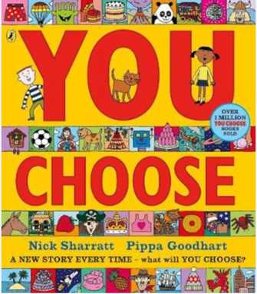 | You Choose  Readers are invited to select their favourite food, destination, clothing, hobby and family from a mix of plausible and not-so-plausible cartoon options | 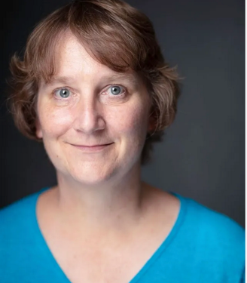  Pippa Goodhart
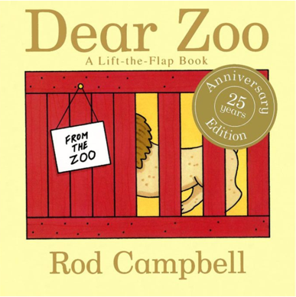 | Dear Zoo  A little boy wants a pet, but the zoo keeps sending him animals that just won’t make good pets. An elephant is too heavy, a giraffe is too tall, and a snake is too scary! Until, at last, they send the perfect pet. | 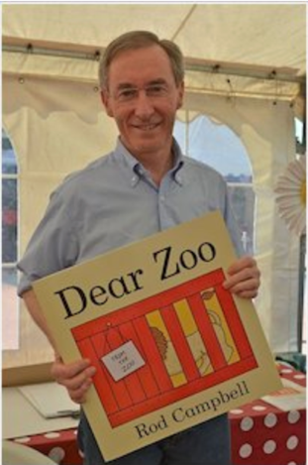  Rod Campbell
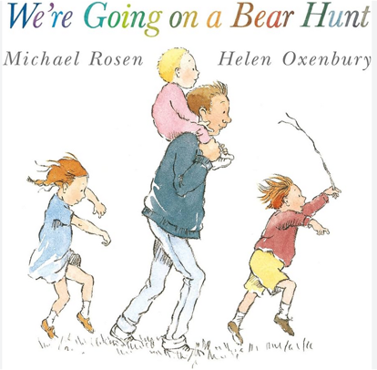 | We’re Going on a Bear Hunt  A family decide to go looking for a bear, and declare – 'we are not scared', but they then face a series of obstacles, including a river, a snowstorm, and a muddy swamp. |   Michael Rosen
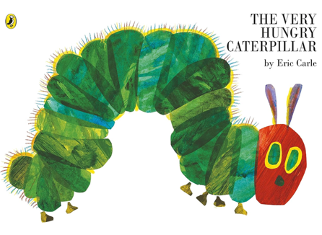 | The Very Hungry Caterpillar  "The Very Hungry Caterpillar" tells the story of a caterpillar that hatches from an egg and, being very hungry, eats a different quantity of food each day of the week. |   Eric Carle
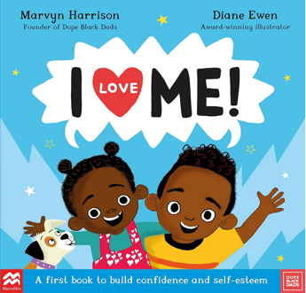 | "I Love Me!" by Marvyn Harrison is a children's book that focuses on building confidence and self-esteem through daily affirmations. It follows two young siblings who, with their father, start each day by looking in the mirror and saying positive statements about themselves. | 

Reception
Cover | Book Title | Author
 | The Proudest Blue  Faizah sees her sister as a princess wearing her beautiful blue hijab, but not everyone at school sees it this way. |   Ibtihaj Muhammad and S.K. Ali
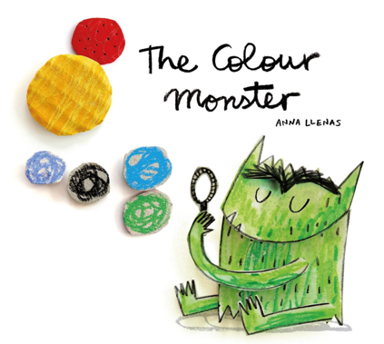 | The Colour Monster  A small girl narrates the story, and begins by introducing her friend, the colour monster. He’s feeling all mixed up and very confused, and the girl explains that it is because his feelings (and colours) are ‘all stirred together’. | 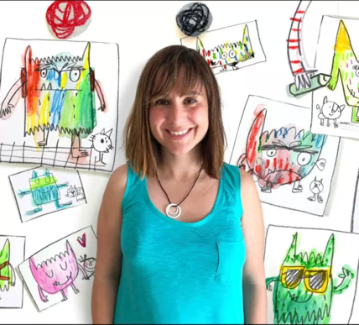  Anna Llenas
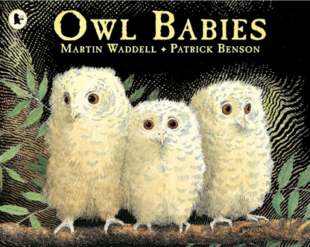 | Owl Babies  In this story, three owls live in a tree with their mother. One night, the three owls discover that their mother is gone and are shocked and upset. |   Martin Waddell
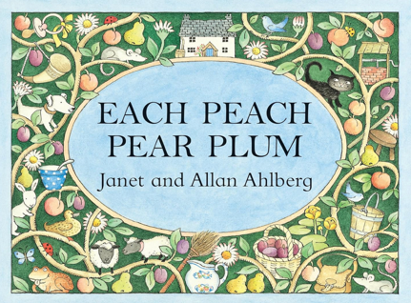 | Each Peach Pear Plum  "Each Peach Pear Plum" by Janet and Allan Ahlberg is a classic children's picture book that uses the "I spy" game as a central theme. | 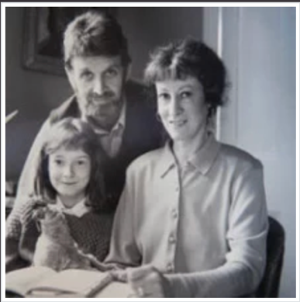  Janet and Alan Ahlberg
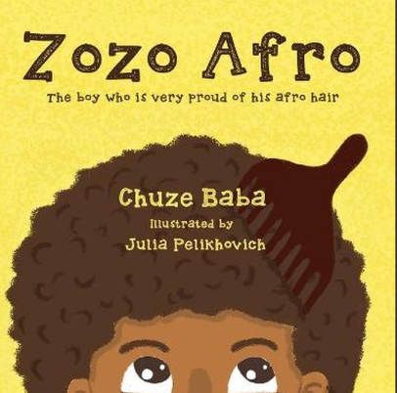 | Zozo Afro  "Zozo Afro" is a children's book about a young boy named Zozo who is proud of his afro hairstyle. The story follows Zozo as he takes his wooden comb and his afro to "Show and Tell," where his classmates are captivated by his hair. |   Chuze Baba
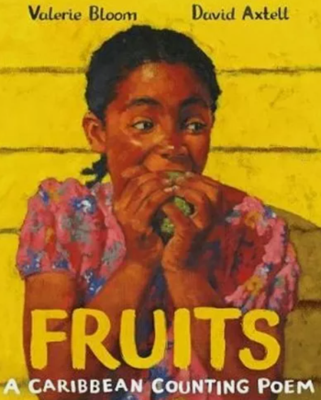 | Fruits  The story follows a young girl who eats her way through different fruits, counting them as she goes, from "half a paw-paw" to "ten June plums" | 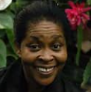  Valerie Bloom

Year 1
Cover | Book Title | Author
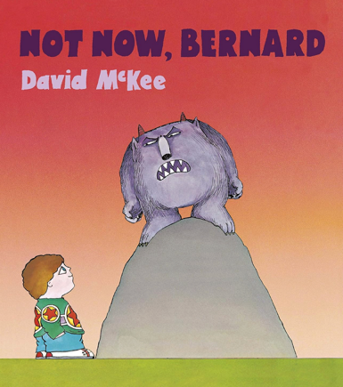 | Not Now Bernard  "Not Now, Bernard" tells the story of a boy named Bernard who tries to get his parents' attention to a monster in the garden, but they are too busy to notice him or the danger. |   David McKee
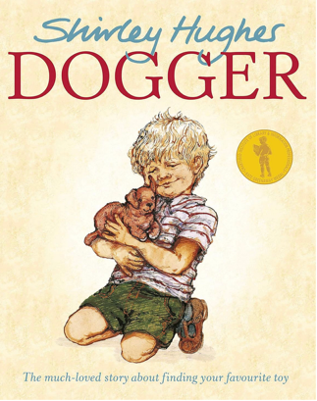 | Dogger  Everywhere Dave goes, his favourite toy, Dogger, is ALWAYS with him. So, when Dogger goes missing, Dave is devastated. | 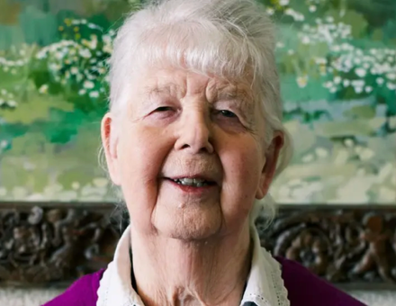  Shirley Hughes
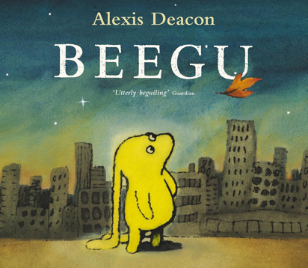 | Beegu  Beegu's spacecraft is stranded on Earth. Now she is lost and wandering. Waiting for a rescue signal from her mother, she fails to make friends with the strange creatures she encounters. |   Alexis Deacon
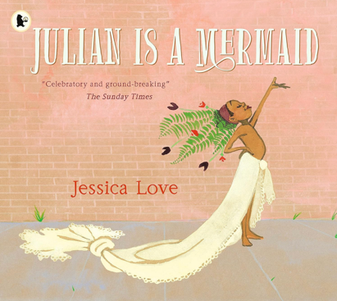 | Julian is a Mermaid  It tells the story of a boy who wants to become a mermaid and participate in the Coney Island Mermaid Parade. | 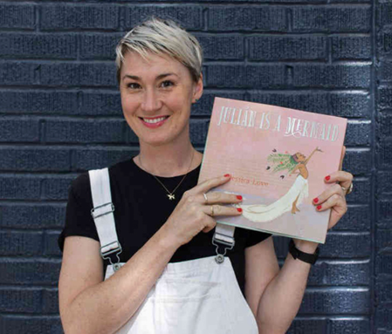Jessica Love
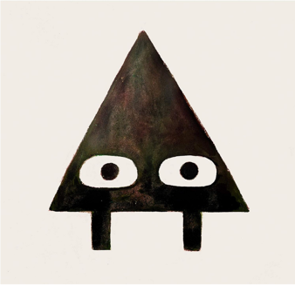 | Triangle  By Mac Barnett and Jon Klassen is a children's picture book about a triangle who plays a trick on his friend, Square, by pretending to be a snake due to Square's fear of them. | 
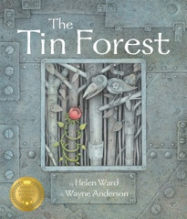 | The Tin Forest  Written by Helen Ward and illustrated by Wayne Anderson, tells the story of an old man living in a barren, windswept wasteland filled with scrap metal. | 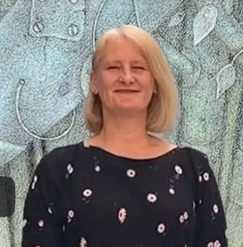

Year 2
Cover | Book Title | Author
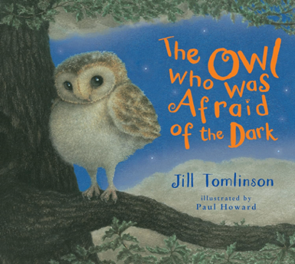 | The Owl Who Was Afraid of the Dark  Plop the barn owl is afraid of the dark. To help him overcome his fear, Mummy Owl sends Plop on a mission to seek out the opinions of others about the dark. | 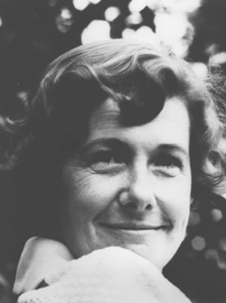  Jill Tomlinson
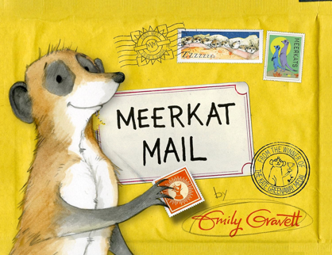 | Meerkat Mail  This book takes you on a journey with a meerkat who is looking for a home that suits him better than his current family home. |   Emily Gravett
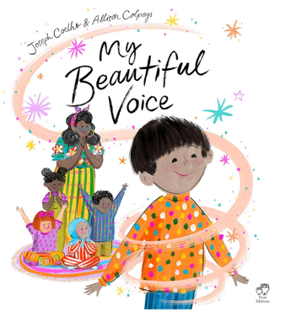 | My Beautiful Voice  Follow a child who is so shy she doesn't speak. With the encouragement on an enchanting and magical teacher, she writes a poem. But a poem is meant to be read aloud! | 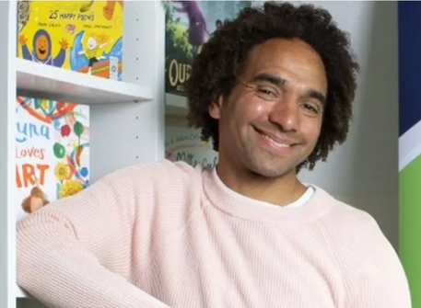  Joseph Coelho
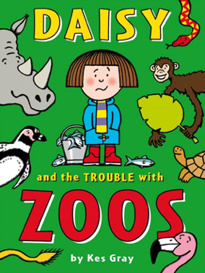 | Daisy and the Trouble with Zoos  Daisy is SO excited because it’s her BIRTHDAY and she’s getting a special treat!  Mum is taking Daisy and her best friends Gabby and Dylan to the zoo. |   Kes Gray
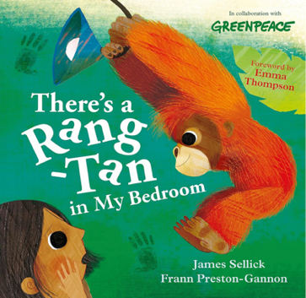 | There’s a Rang-Tan in my Bedroom  A cute but rather badly behaved little orangutan has appeared in a little girl's bedroom, throwing away chocolate and howling at the shampoo in the bathroom. |   James Sellick
Year 3
Cover | Book Title | Author
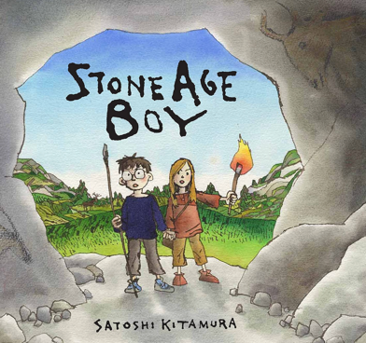 | Stone Age Boy  One day a little boy is walking along when he trips, stumbles and falls ... into the Stone Age! |   Satoshi Kitamura
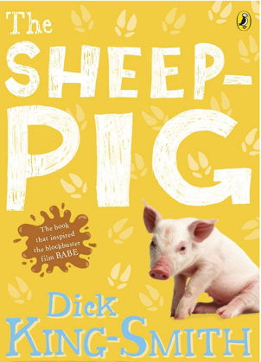 | The Sheep Pig  "The Sheep-Pig," tells the story of an orphaned piglet named Babe who is raised by a kind sheepdog named Fly |   Dick King Smith
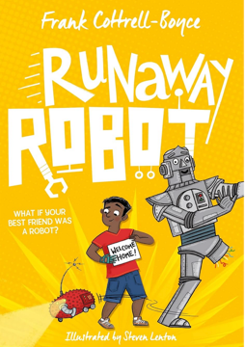 | The Runaway Robot  "The Runaway Robot," is a story about Alfie, a boy with a robotic hand, who goes to Airport Lost Property and finds Eric, a giant, nearly 100-year-old robot, who is also missing a leg and half his memory. |   Frank Cottrell Boyce
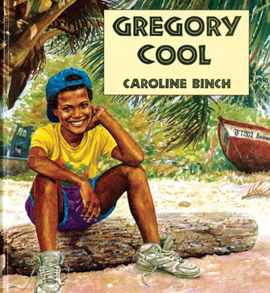 | Gregory Cool  It tells the story of young Gregory as he sets about on his first day in Tobago with his grandparents. | 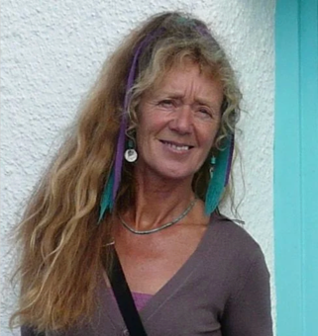  Caroline Binch
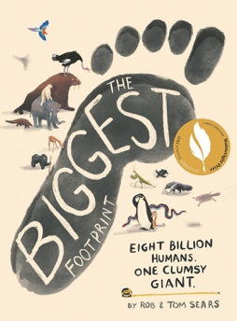 | The Biggest Footprint  By Rob Sears and Tom Sears is a children's book that uses the concept of a "mega human" – a giant formed by combining all 8 billion humans – to explore humanity's impact on the planet | 
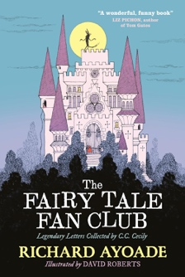 | The Fairy Tale Fan Club  Legendary Letters collected by C.C. Cecily" by Richard Ayoade is a collection of humorous letters between fairy tale characters and their fans, as compiled by the Senior Secretary of the Fairy Tale Fan Club | 

Year 4
Cover | Book Title | Author
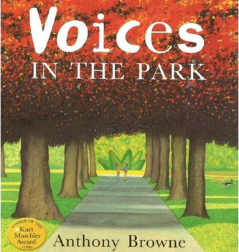 | Voices in the Park  "Voices in the Park" tells the story of a visit to a park through the perspectives of four different characters: a bossy woman, a sad man, a lonely boy, and a warm-hearted girl. |   Anthony Browne
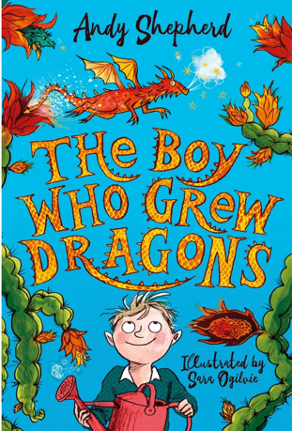 | The Boy Who Grew Dragons  Tomas, who discovers a strange tree in his grandad's garden and takes its fruit home, where a tiny dragon, Flicker, hatches. |   Andy Shepherd
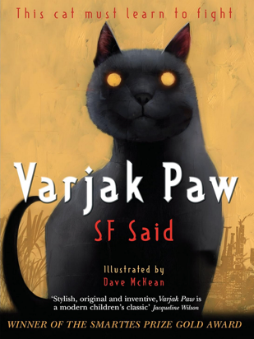 | Varjak Paw  A pampered house cat named Varjak leaves his family's isolated home to discover the secrets of the "Vanishings," a mysterious phenomenon plaguing the city. |   S.F. Said
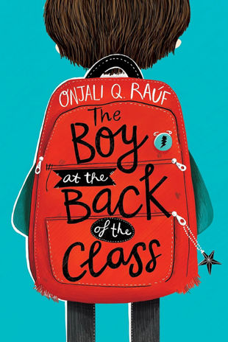 | The Boy at the Back of the Class  This is the story about how one ordinary nine-year-old child and three classmates are full of empathy for Ahmet, a boy that comes to their school as a refugee from Syria. |   Onjali Rauf
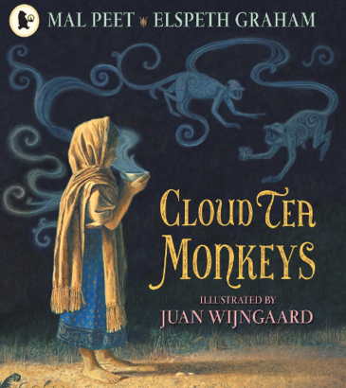 | Cloud Tea Monkeys  Monkeys come to the rescue of a struggling family in this traditional tale from a Carnegie Medal winner. Tashi lives in a tiny village below the tea plantations where her mother earns a living. One day her mother falls ill, and Tashi must pick tea to earn the money for a doctor. |   Mal Peet

