Leedon’s Little Learners
Cover | Book Title | Author
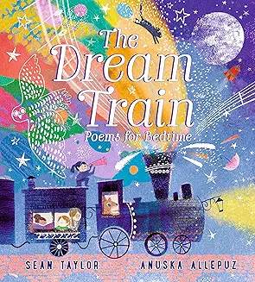 | The Dream Train: Poems for Bedtime | Sean Taylor
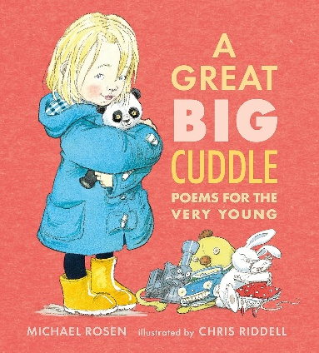 | A Great Big Cuddle – Poems for the Very Young | Michael Rosen
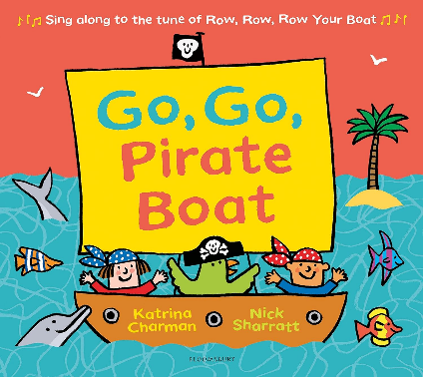 | Go, Go, Pirate Boat | Katrina Charman

Reception
Cover | Book Title | Author
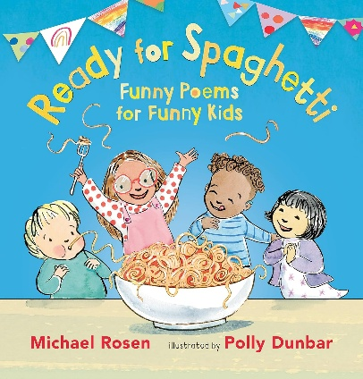 | Ready for Spaghetti | Michael Rosen
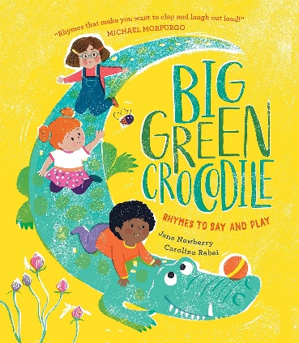 | Big Green Crocodile – Rhymes to Say and Play | Jane Newberry
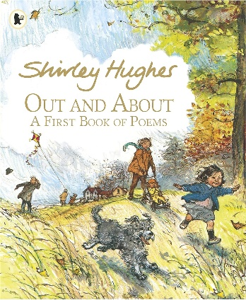 | Out and About A First Book of Poems | Shirley Hughes

Year 1
Cover | Book Title | Author
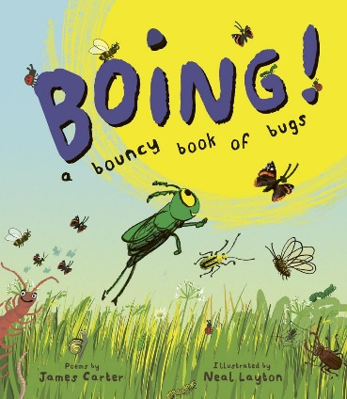 | Boing | James Carter
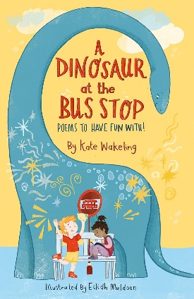 | A Dinosaur at the Bus Stop | Kate Wakeling
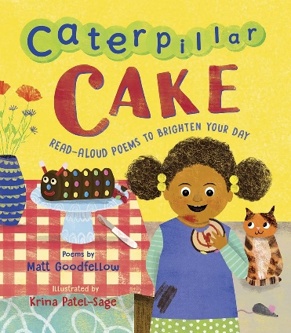 | Caterpillar Cake | Matt Goodfellow
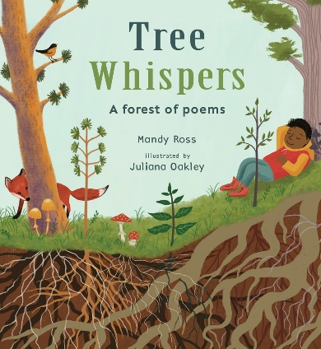 | Tree Whispers | Mandy Ross

Year 2
Cover | Book Title | Author
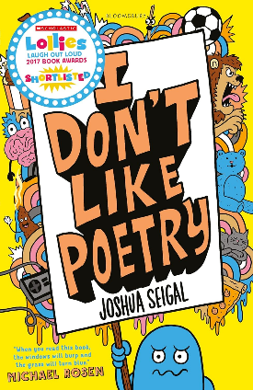 | I Don’t Like Poetry | Joshua Seigal
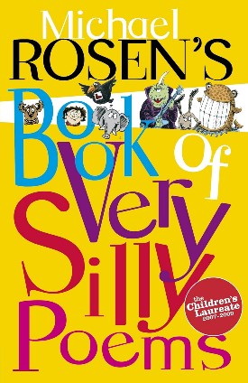 | Book of Very Silly Poems | Michael Rosen
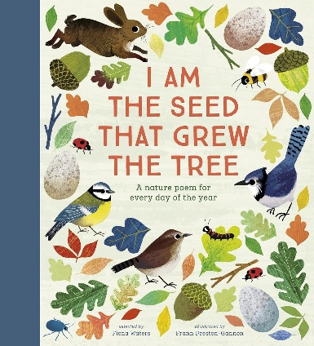 | I Am The Seed that Grew the Tree | Fiona Waters
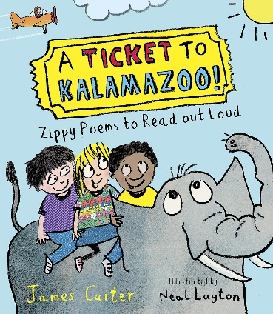 | A Ticket to Kalamazoo | James Carter

Year 3
Cover | Book Title | Author
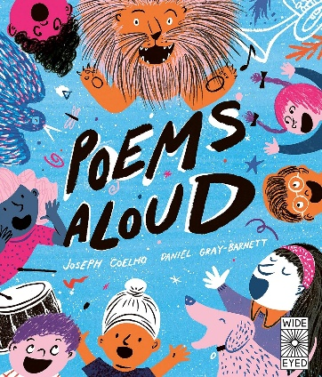 | Poems Aloud | Joseph Coelho and Daniel Gray-Barnett
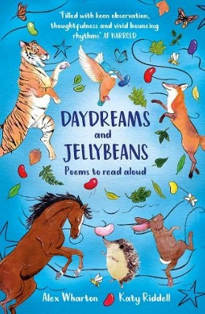 | Daydreams and Jellybeans | Alex Wharton and Katy Riddell
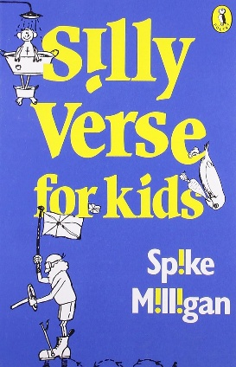 | Silly Verse for Kids | Spike Milligan
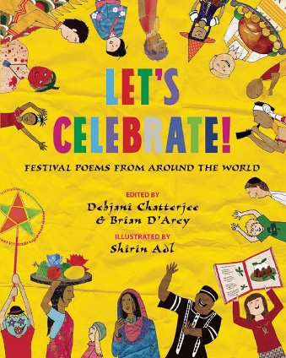 | Let's Celebrate! Festival Poems from Around the World | Debjani Chatterjee and Brian D'Arcy

Year 4
Cover | Book Title | Author
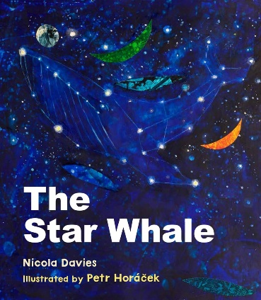 | The Star Whale | Nicola Davies
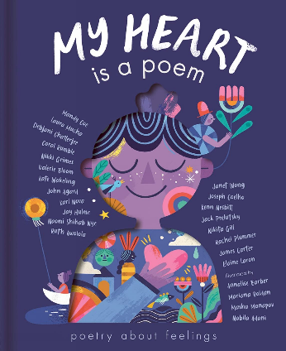 | My Heart is a Poem | Various
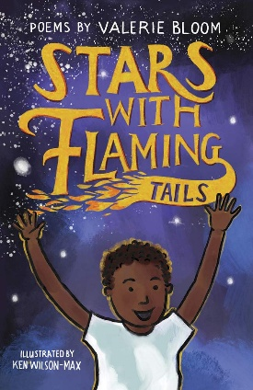 | Stars with Flaming Tails | Valerie Bloom
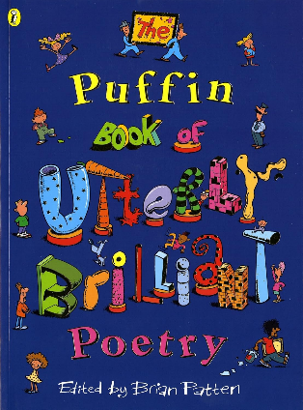 | The Puffin Book of Utterly Brilliant Poetry | Various

