Home Learning for Year Four

November 2020

Dear Children and Families,

Please find below information on resources that you may wish to use at home. These are websites and apps which can be used during self-isolation, any possible future lock-downs or for extra learning during evenings or weekends if you should wish to do some.

Seesaw - https://app.seesaw.me/#/login

Seesaw is an app and website which allows us to share the children’s learning between school and home. You will need to use the QR code for your child’s class to start off (found below) and you will be able to upload photos, videos, documents and messages to the teachers, who will then respond to you. The children can also comment on each other’s learning and these comments are moderated by school staff. Please be aware that logging in using the QR code confirms that you agree to the terms and conditions of the service.

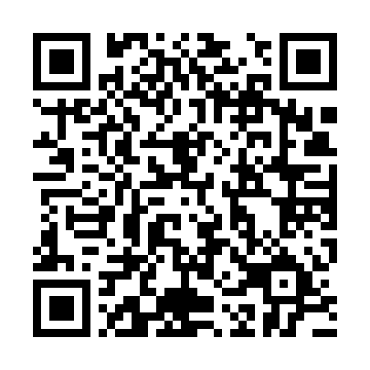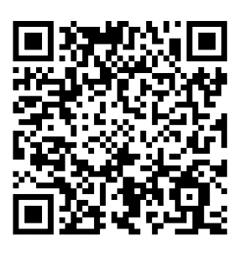

Moon QR code Galaxy QR code

Times Tables Rock Stars - https://play.ttrockstars.com/auth

Called TTRS for short, this is a website which helps children to learn their times tables and related division facts. Each child has been given a username and password and has been set certain focus times tables as their target. To get to these tables, please click on the Garage tab. If you click on the Studio tab, you will be given all of the times tables up to 12 x 12 and this can be quite demoralising for younger children but it’s well worth a go if you’re feeling brave!

DoodleMaths - https://www.doodlemaths.com/#!

DoodleMaths is an app and website where the children can practise all aspects of the Maths curriculum. When the children login, they will be presented with a 5-a-day challenge. The built-in algorithms will adapt the questions to your child’s ability and gaps in understanding.

Bug Club / Active Learn - https://www.activelearnprimary.co.uk/login?

Bug Club is a reading resource, which is set to the current book band of your child. It provides a selection of stories and non-fiction texts for your child to read or for you to read to them. There is also a function whereby the computer reads the book aloud. Comprehension questions are built in to each book.

The school code is leed.

If you have any difficulty accessing any of these resources, please watch the support videos found at;

<https://www.leedonlowerschool.co.uk/year-1-and-2/>

If you still need further information or help, please contact Gemma O’Reilly via her email;

[goreilly@leedonlowerschool.co.uk](mailto:goreilly@leedonlowerschool.co.uk)

Many thanks,

The Year Four Team.