Chilly Chilli ILA

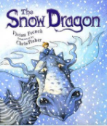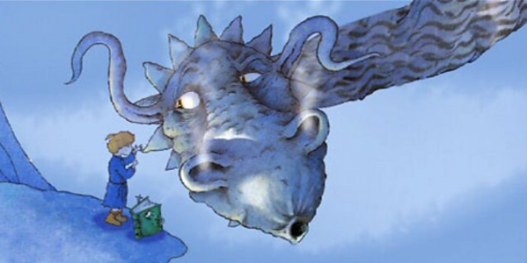

Art Activity

Your task this afternoon is to create your very own Snow Dragon.

You can use any materials you have. Here are some ideas:

Paint

Chalk

Collage – maybe an old magazine

Craft

Recycling material

Material (you could make a huge snow dragon using clothes!)