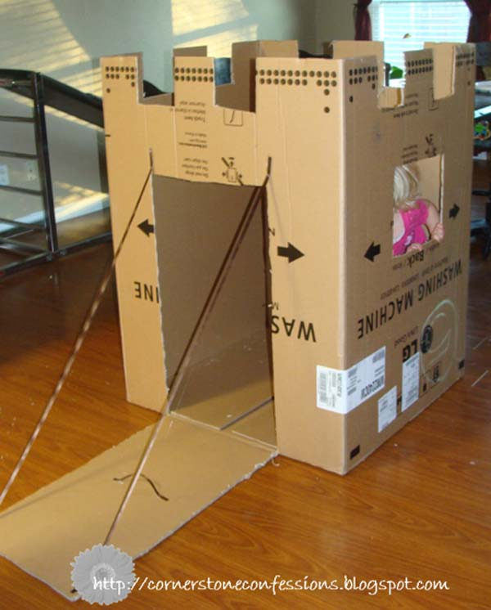

**brown, brick walls**

**high, tall turrets**

**protective, rising drawbridge**