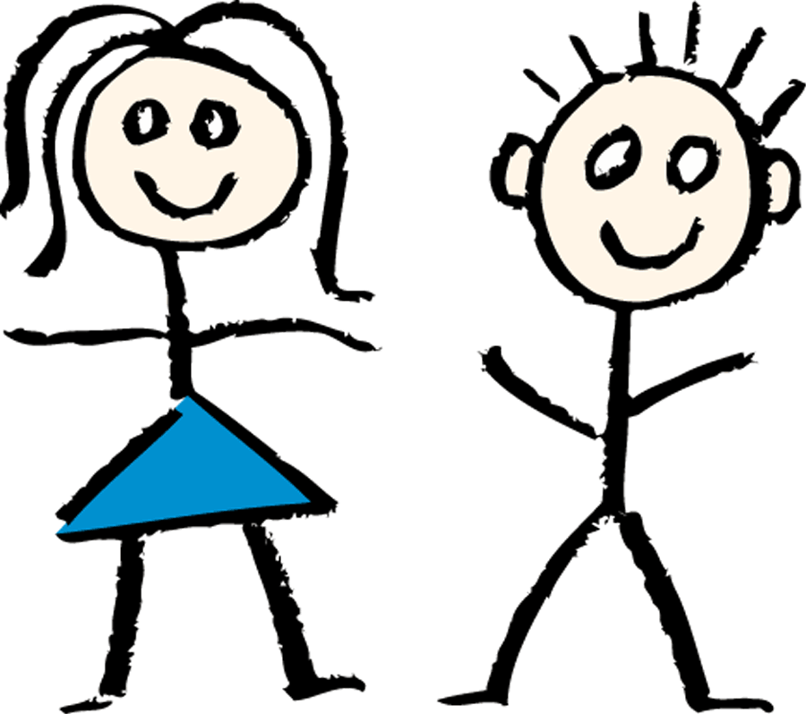 

|  |  |
| --- | --- |
| Hola | __________________________  Como te llamas? |
| Me llamo Maria. Y tu? |  |
| ¿Que tal?  (How are you?) | _________________________  _________________________  (Good thanks, and you?) |
| _________________  (Good thanks) | _________________  (How old are you?) |
| Tengo cinco años, y tu?  (I’m 5 years old, and you?) | ________________________________________________________ (I’m 6 years old) |
| Adios Pedro  (Goodbye Pedro) | (Goodbye Maria) |

|  |  |
| --- | --- |
| Hola Pedro | Hola Maria |
| ¿Que tal?  (How are you?) | ___________________  ______________________________________  (Good thanks, and you?) |
| ___________________  (Good thanks) | ___________________  (How old are you?) |
| Tengo cinco años, y tu?  (I’m 5 years old, and you?) | ___________________  (I’m 6 years old) |
| Adios Pedro  (Goodbye Pedro) | (Goodbye Maria) |



|  |  |
| --- | --- |
| Hola Pedro | Hola Maria |
| ¿Que tal?  (How are you?) | ___________________  ______________________________________  (Good thanks, and you?) |
| ___________________  (Good thanks) | ___________________  (How old are you?) |
| Tengo cinco años, y tu?  (I’m 5 years old, and you?) | ___________________  (I’m 6 years old) |
| Adios Pedro  (Goodbye Pedro) | (Goodbye Maria) |