*11.1.21*

*Property of Materials: Bouncing Ball Investigation*

*LO: Can you investigate what make some balls bounce more than others and why?*

*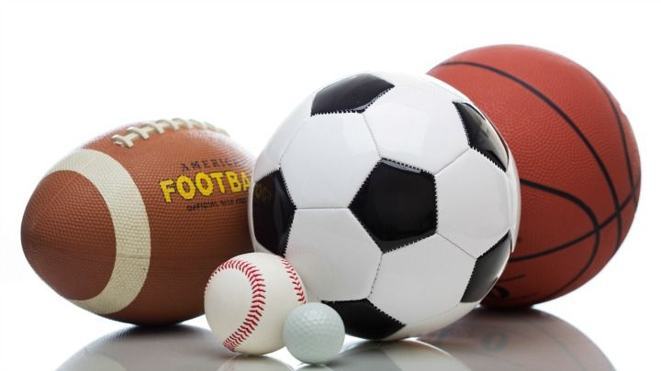*Would you choose a ball of plasticine to play tennis or table tennis? Why not?

*What sort of balls do you think will bounce best?*

*Why do you think balls bounce?*

Balls bounce because they are elastic. When a ball hits a hard surface its shape changes – the part touching the ground flattens slightly. It gets back into its original shape quickly and bounces back up.

Watch this video of a ball bouncing in slow motion. <https://www.youtube.com/watch?v=1HiXQrLigwo>

Find some different balls to bounce. You will need a hard surface to test them on.

*How are we going to test the bounciness of these balls? How will we make it fair so that we treat all the balls the same?*

How can we measure which ball bounces the highest?

How can you record your results?

*Do you think balls bounce well on sand? Do they bounce well on wood?*

Take just one of the balls – a fairly bouncy one – and drop it onto different surfaces, e.g. carpet, wood, tiles, and note the height of the bounce.

What do you notice?

Are your results different? Why?