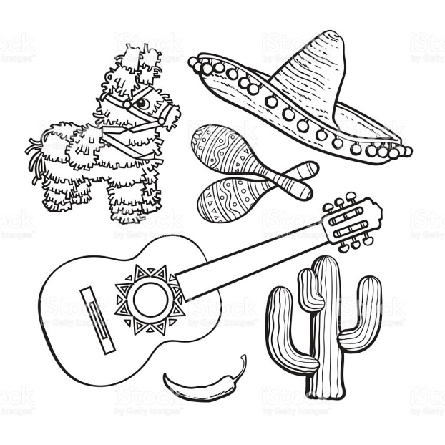 Nombre (Name): _____________________

Hola - ___________

Clase (Class): __________



Gracias - _________________

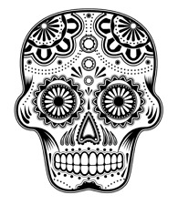

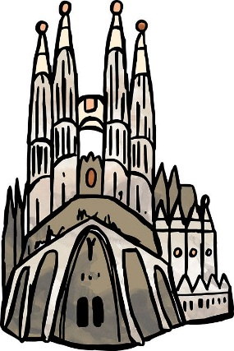



Adios - ______________

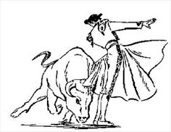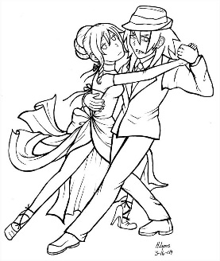**¡OLE!**

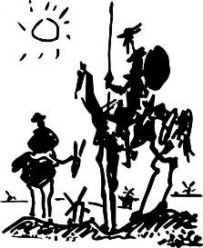¡ESPAÑOL!

(Spanish)

|  |
| --- |
| ¡ESPAÑOL!  Image result for BW drawing flamenco  Nombre (Name):  ________________  Clase (Class):  _______________  Image result for drawing speedy gonzales  Image result for BW drawing tango  Image result for drawing spanish  Image result for BW drawing day of the dead  Related image |

|  |
| --- |
| ¡ESPAÑOL!  Image result for BW drawing flamenco  Nombre (Name):  ________________  Clase (Class):  _______________  Image result for drawing speedy gonzales  Image result for BW drawing tango  Image result for drawing spanish  Image result for BW drawing day of the dead  Related image |