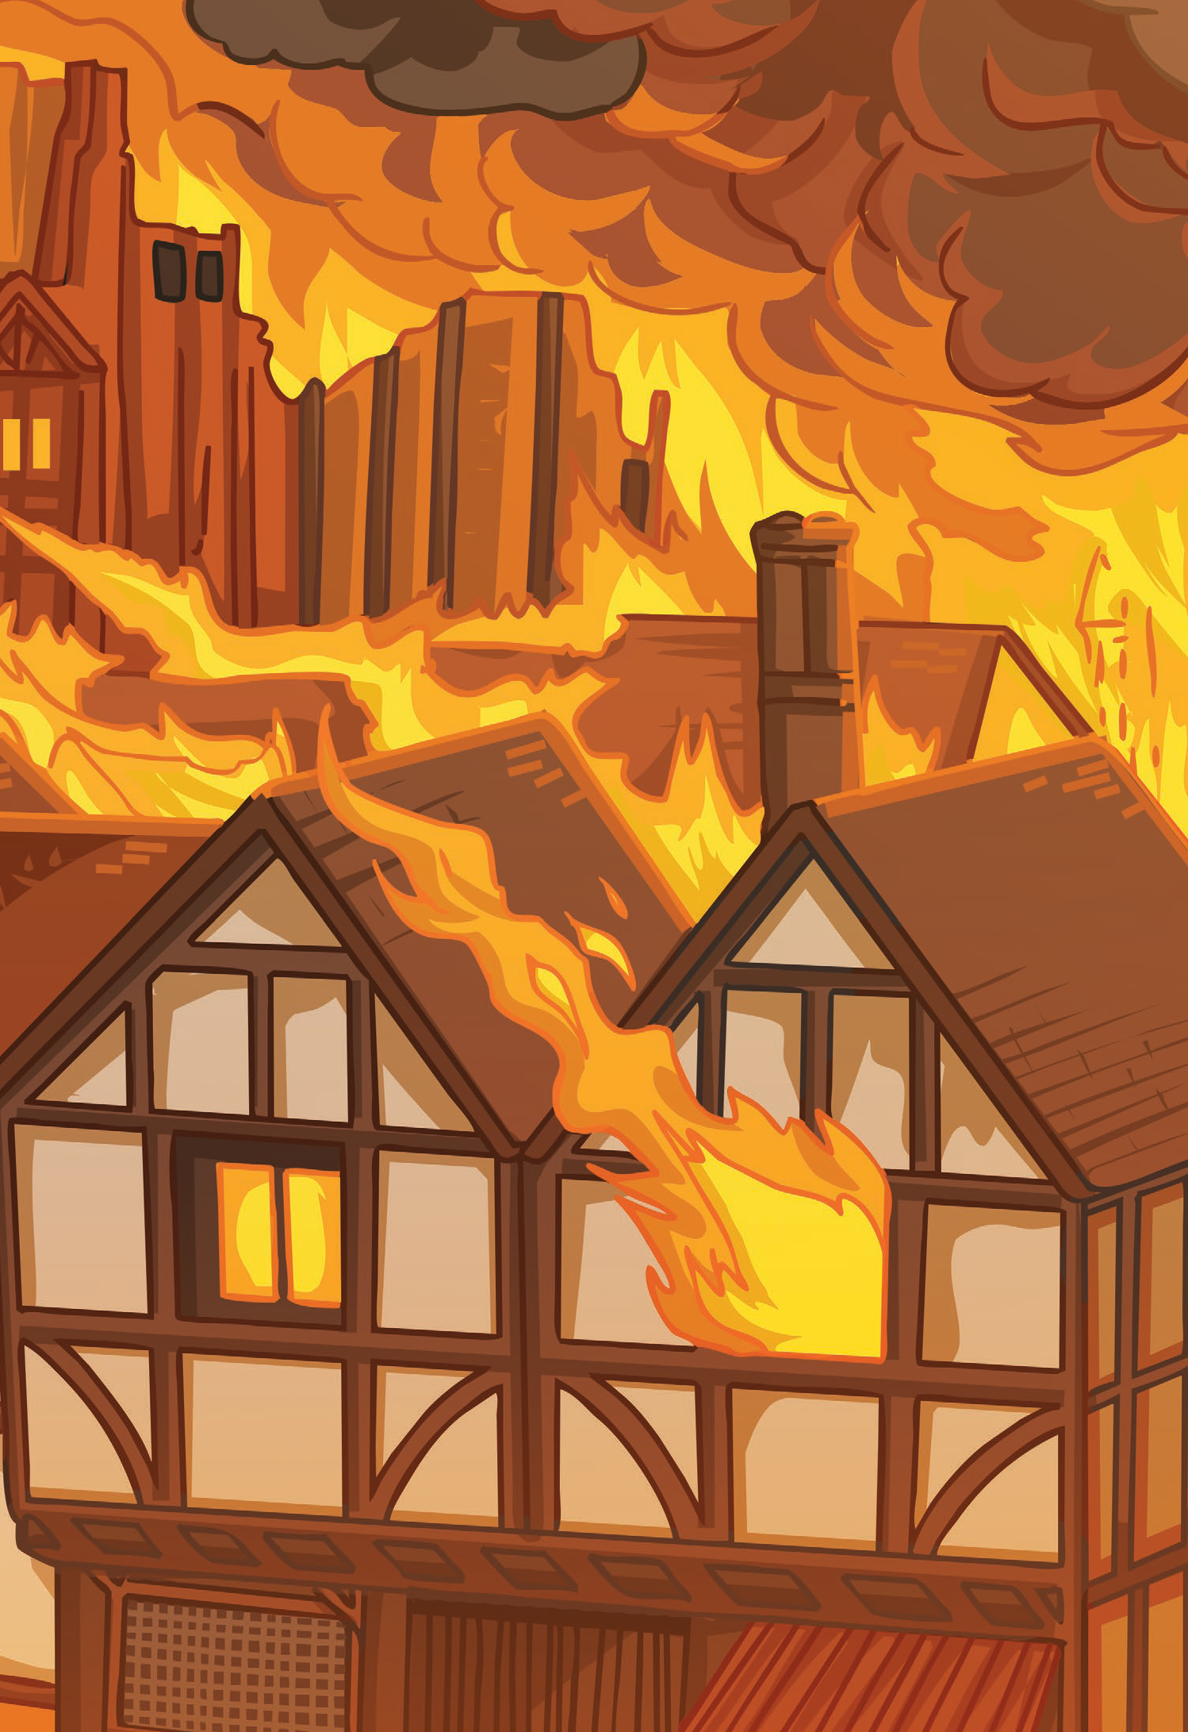

Art

Today we are looking at ways of mixing colours.

Did you know that all colours are made by mixing the 3 **primary** colours – red, yellow and blue?

If you mix two primary colours together they make **secondary** colours:

Red + yellow = orange

Yellow + blue = green

Blue + red = purple

**Tertiary** colours are made when you combine the primary and secondary colours together. What colours do you think they make?

Black and white is then used to lighten or darken colours.

Some of the colours we mix can be described as **cool** – greens, blues, purples, greys

And some are **hot** – yellows, oranges, reds, pinks

As our topic this half term is all about fire, we are going to find out how many hot colours we can make by using yellows and reds.

You will need – red, yellow, white, black paint. Paper. Brush.

**If you don’t have paint you can also use pastels or coloured pencils- just blend the colours over each other.**

**Or you could look around your home and see if you can make a collage of hot colours using magazines, material etc.**

1. Fold a piece of paper into 8 or 16 rectangles.
2. Start with some yellow and paint one rectangle.
3. Add a very small amount of red paint – the less the better – mix and watch it change colour.
4. Paint another rectangle.
5. Repeat the process until you have mainly red.

**What happens if you add white? Or black?**

**Challenge yourself to make as many different hot colours as you can!**