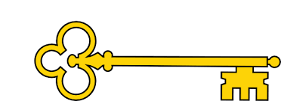

Facts

I can explain who Amelia Earhart is
I can explain how cars have changed in the last few years
I can tell you the name of the first plane that flew and when it took
flight
I can explain how planes have changed
I can label a steam locomotive
I can explain the timeline of locomotives
I can tell you who the Wright brothers are

Previously…
In EYFS children learnt to Comment on images of familiar situations in the past and compare and contrast characters from stories, including figures from the past.
Year 1
History
Planes, Trains + Automobiles
History
Next...
In Year 2 children learn to understand chronology and study of a historical event.
Planes, Trains + Automobiles
Year 1
Spring Term

Doors this will open…
Historian
Teacher
Museum curator
Archaeologist
Academic researcher.
Archivist.
Heritage manager
Vocabulary

Plane - biplane / pilot / aviator pioneer

Atlantic Ocean

Train – steam engine / locomotive / narrow gauge / railway

Car – petrol / diesel / electric

Questions

How have cars changed in the last few years?
What does it mean if a car is electric?
When was the first plane flight?
How have planes changed?
Who is Amelia Earhart?
Why is Amelia Earhart important?
What is a narrow gauge railway?
What is a steam locomotive?
How are the Wright brothers?
Links

Maths – reading dates / timelines
Literacy – Amelia Earhart biography and labelling steam engines
DT –creating a moving picture
Images
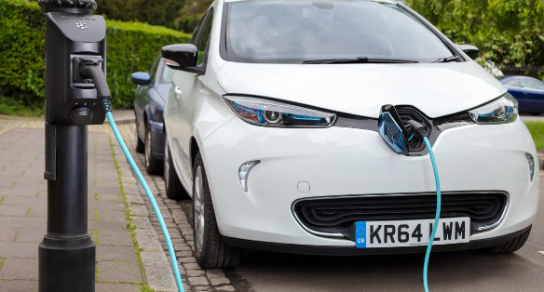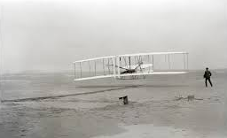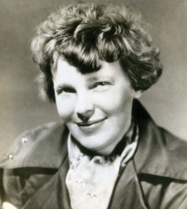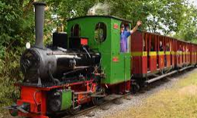
Our Learning Keys

