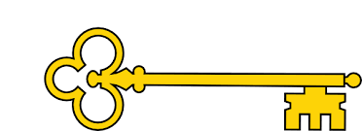
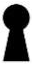
History
Next...
In Year 2 children learn to understand chronology and study of a historical event.
Year 1
History
Florence Nightingale
Previously…
In EYFS children learnt to Comment on images of familiar situations in the past and compare and contrast characters from stories, including figures from the past.
Florence Nightingale
Year 1
Autumn Term

Doors this will open…
Historian
Teacher
Museum curator
Archaeologist
Academic researcher.
Archivist.
Heritage manager
Facts

I can explain who Florence Nightingale is
I can explain what a nurse does
I can explain the impact Florence Nightingale has had
I can explain the differences between then and now
I can compare a hospital from the 1850’s to a hospital today
I can tell you what germs are and the impact they can have
I can explain how and why we wash our hands

Vocabulary
Germs Investigate
Observe Predict
Timeline Order
More recent Past
Present Germs
Hospital Ward
Clean Dirty
Nurse Doctor
Evidence Conclusion
Change Mould

Questions

Who is Florence Nightingale?
What was her job?
Where / when did she live?
Why is it important to keep our hands clean?
Why was Florence Nightingales work important?
What year are we in?
What does a nurse do?
How has Florence Nightingale’s work influenced the way we think about the transfer of germs?
Links

Science – investigations / fair experiments
PSHE – personal hygiene / people who help us
Geography – map of the world

Images
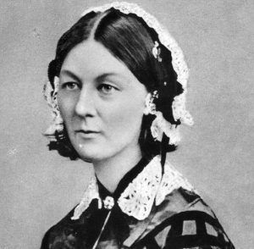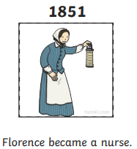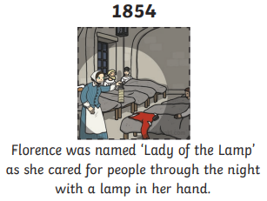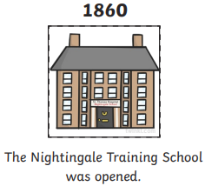
Our Learning Keys

