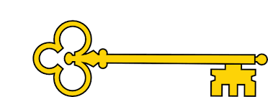

**Vocabulary**

Map Ocean

Features World

Ariel view Continent

United Kingdom Capital City

Pacific Ocean Atlantic

Indian Arctic Southern Antarctica

Europe Asia

Africa Australia

North America South America

**Questions**

How many oceans are there?   
What are the 5 oceans called?

How many continents are there?   
Can you name all 7 continents?   
Can you show me on a map where the ­­­­____ ocean is?

Can you show me on a map where the continent _____ is?

What is an ocean?   
What is a continent?

What continent do we live in?

What ocean surrounds the UK?

Can you name and locate the four countries and capital cities of the UK?

**Next...**

In Year 2 children use world maps, atlases and globes

Year 1

Geography

Oceans + Continents

**Previously…**

In EYFS children draw information from a simple map. Recognise some similarities and differences between life in this country and life in other countries and recognise some environments that are different from the one in which they live.

Oceans + Continents

Year 1

Spring Term

**Doors this will open…**

Geography teacher.

Geographer..

Landscape architect.

Travel writer.

Environmental scientist.

Environmental consultant.

Geography

**Facts**

I can explain what an ocean is

I can name the 5 oceans

I can explain what a continent is

I can name the 7 continents

I can locate the UK on a map

I can locate and name the four countries of the UK

I can locate and name the four capital cities of the UK

**Links**

Maths – positional language

Literacy -Geographical texts

Science – weather

**Images**

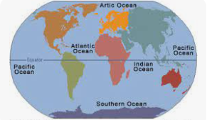 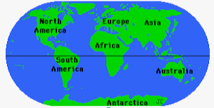 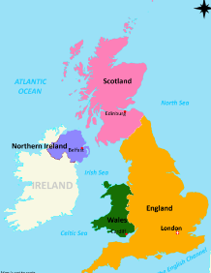

Our Learning Keys