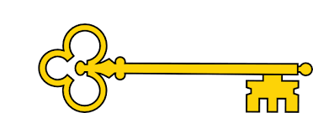

**Next...**

In Year 2 children use world maps, atlases and globes

Year 1

Geography

The Green school – Tulum, Mexico

**Previously…**

In EYFS children draw information from a simple map. Recognise some similarities and differences between life in this country and life in other countries and recognise some environments that are different from the one in which they live.

The Green School – Tulum, Mexico

Year 1

Autumn Term

**Doors this will open…**

Geography teacher.

Geographer..

Landscape architect.

Travel writer.

Environmental scientist.

Environmental consultant.

Geography

**Facts**

I can name the four seasons

I can compare weather between two countries

I can describe our school environment and name its key features

I can describe The Green School environment and name its key features

I can talk about physical and human features of two contrasting schools

I can share ideas about how we can make our school ‘greener’

I can show where I live on a world map

I can explain the difference between human and physical features

**Vocabulary**

Map Ariel view

Climate Continent

Weather Miles

Features Compass

Scale Green

World Environment

Human features / Physical features

Seasons – spring / summer / autumn / winter

Green

**Questions**

Can you name the four seasons?

Where is Tulum?

What does ‘green’ mean?

What is an aerial view?

What is a compass used for?

What are the similarities between the two schools?

What are the differences between the two schools?

Where is the UK on a map?

How do the two countries weather contrast?

**Links**

Science – seasonal changes

/ dressing for appropriate weather

PSHE – looking after our environment

Maths – positional language

Literacy -Geographical texts

**Images**

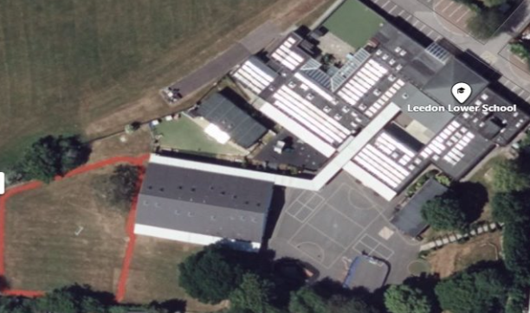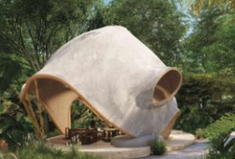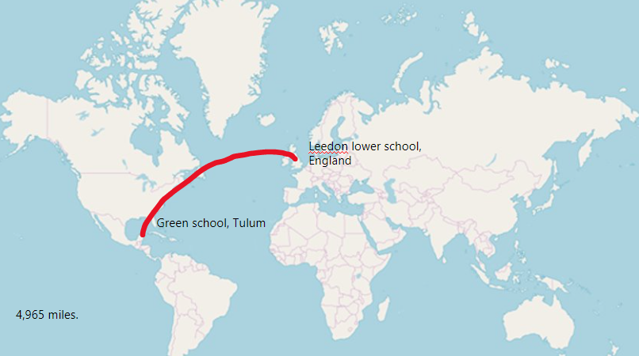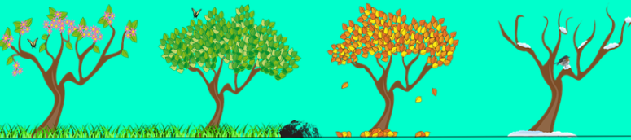

Our Learning Keys