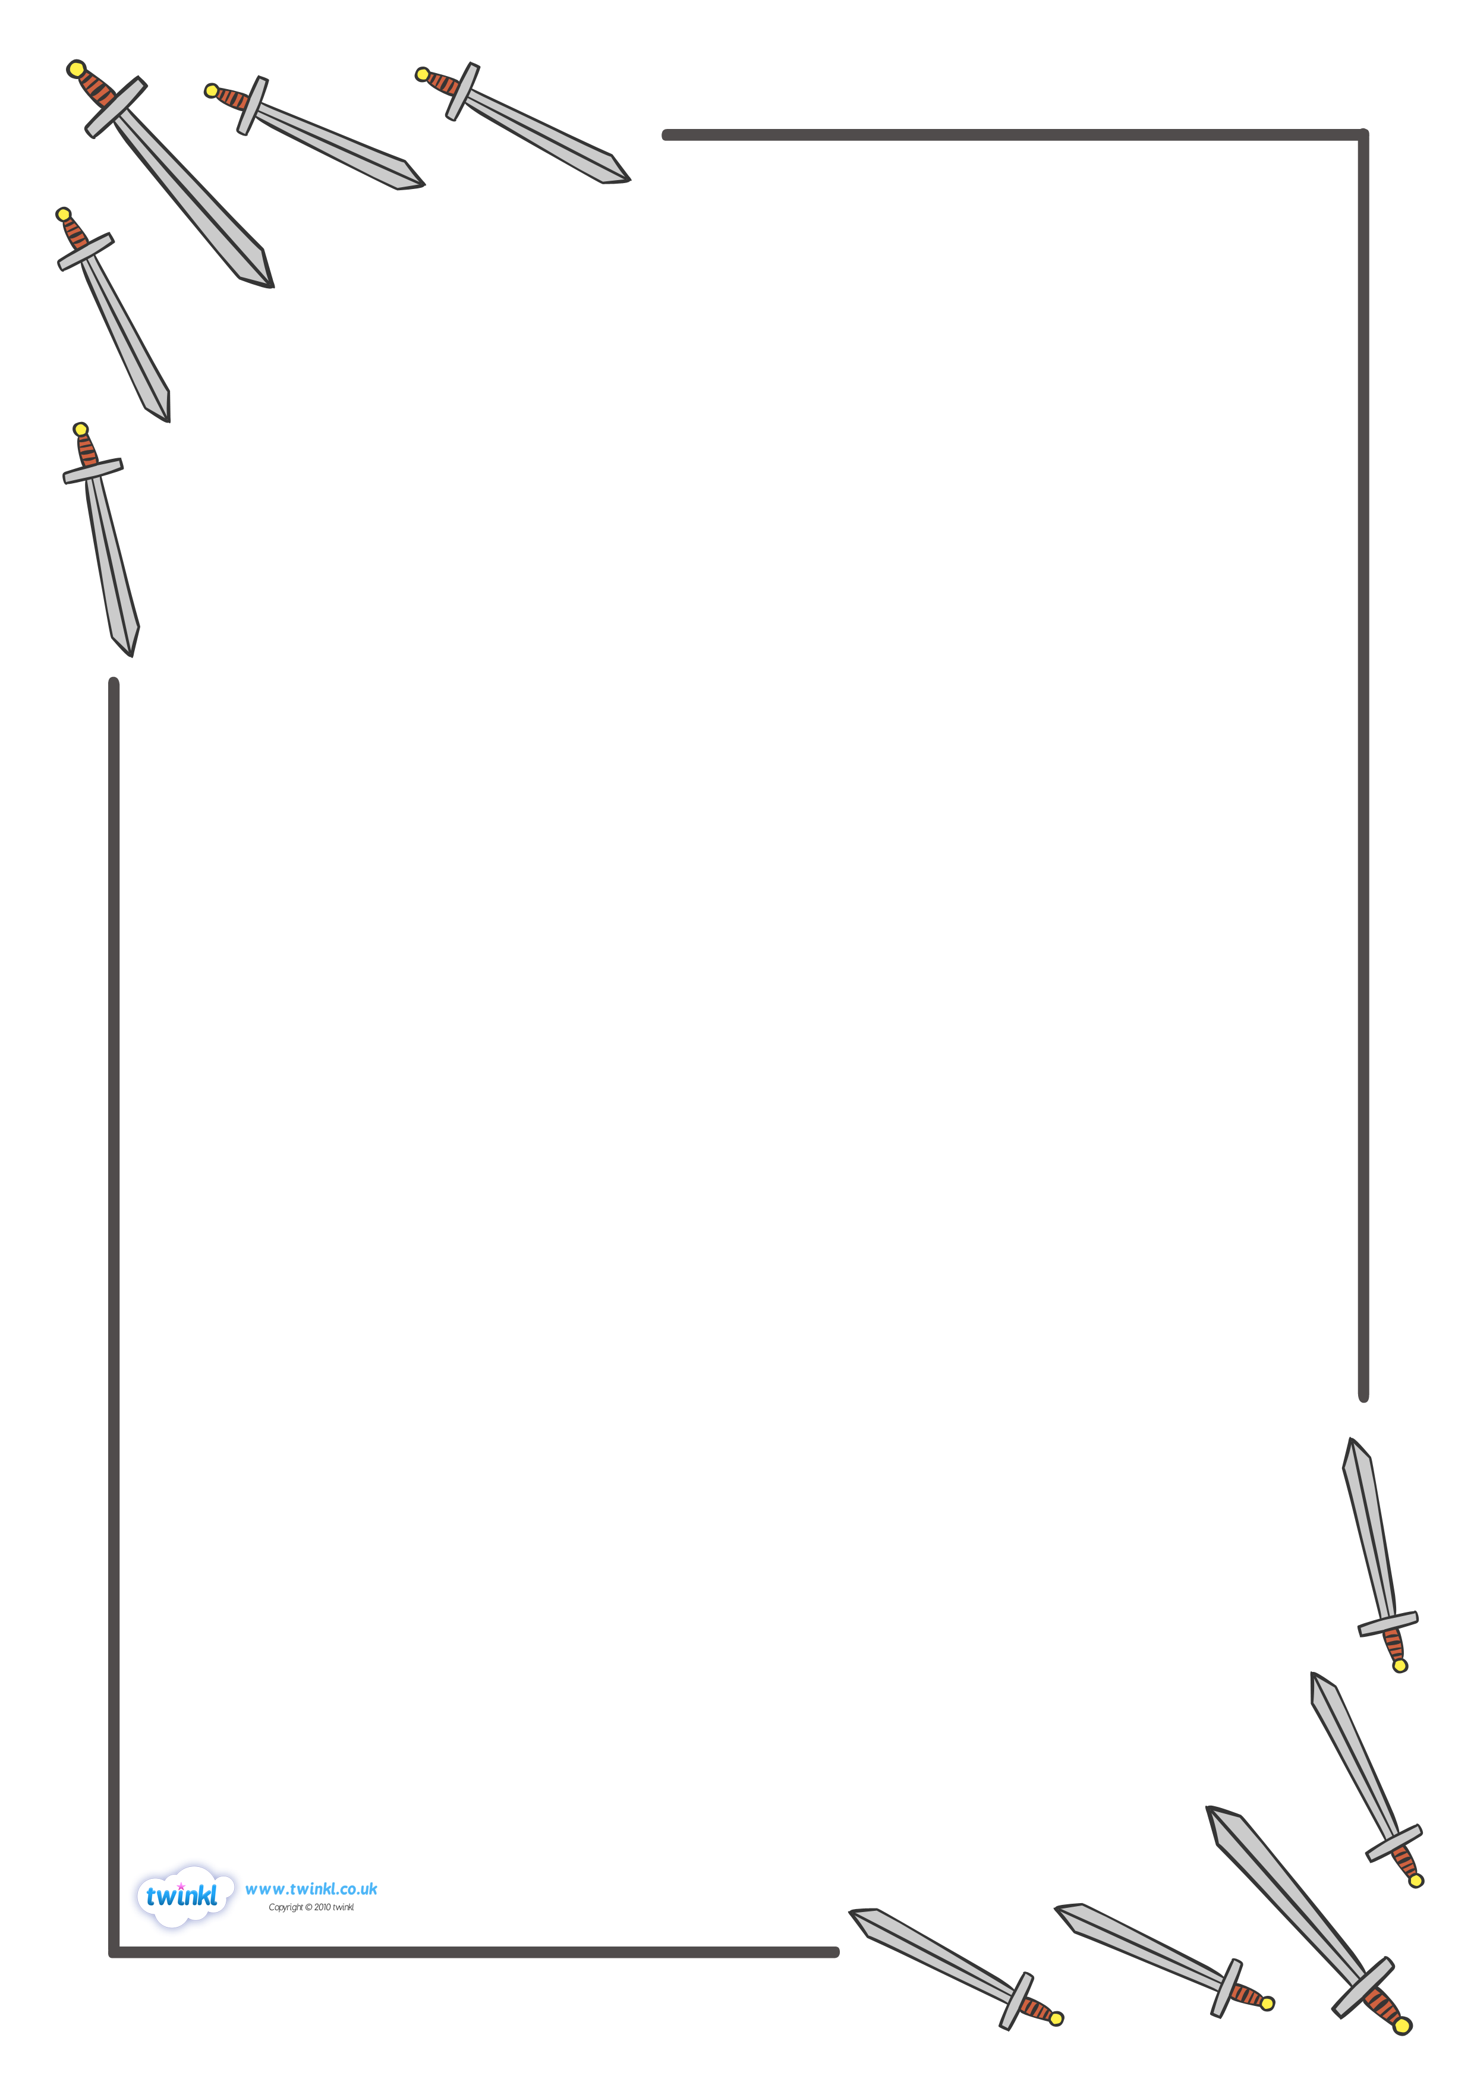
TEXT HERE

Ruby’s Sword
By Jacqueline Veissid
 | What to do | Why we are  doing this
Monday | Listen to the story and read along if you can.  Ask your grownup if there are words you don’t understand or know the meaning of.  Can you draw a story map of Ruby as she follows her brothers and finds her swords? Can you label some of the things she sees? | It is important to understand the language we see in a text – it helps to improve our vocabulary.  A story map is a good way of remembering the events and order of a story.
Tuesday | Can you see how many verbs (doing words) you can spot?  Make a list of them.  Can you think of some more?  Write some verbs on  pieces of paper.  Play a game of charades (act out the action) using the verbs.  Who can guess the most? | It is important to know the different jobs words have in a text –  Nouns = people, places or objects.  Verbs = action words.  Adjectives = describing words.
Wednesday | The author uses alliteration in the story –‘warm wind’, ‘bending blades’. Can you find all of the alliteration in the story?  Go outside and listen, look, and smell the things around you. Can you find words to describe some of the things you see? ‘Green grass’, ‘flapping, fluttering wings’,  Can you draw or write what you see? | Have you noticed how some of the words and phrases in the story start with the same letter? This is called alliteration.  Authors use it to make their writing more interesting.
Thursday | Imagine you are Ruby, chasing after her brothers. Where would you go? What would you see? What would you discover? Would you build something together like they did?  Can you plan a short story of your own, text map it using pictures and words. | Using another authors ideas is like being a magpie – you take the good bits and make them your own.  Lots of authors do this.  You are going to be an author of your own story.
Friday | Using all the ideas you’ve gathered this week – the verbs, alliteration, becoming familiar with the story and creating your own ideas.  Today we would like you to put all those ideas together to write your own story. | It is important to use your writing skills – don’t forget capital letters and fullstops!  And when you finish you  must read what you have written!

