Budapest is the capital of Hungary in the heart of Europe. Come and visit this diamond to experience the kindness of Hungarian people and to enjoy the food and wine of the region!
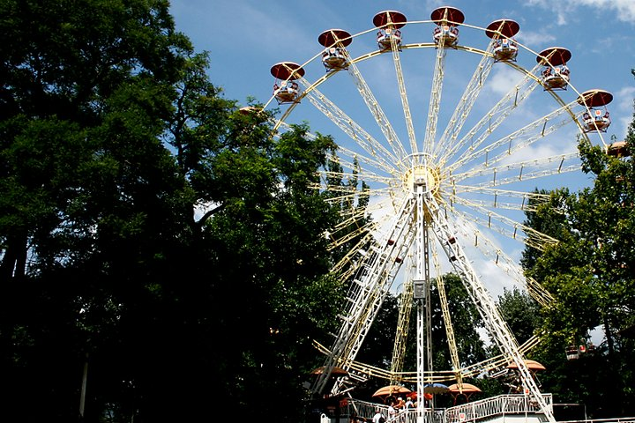
Things to do
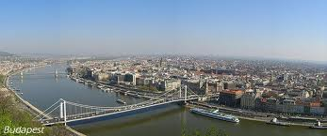
Do you have small children? Why not go and visit the Budapest Zoo and Theme Park which is one of the most amazing zoos in Europe with more than 1000 different species from Polar bears to crocodiles and tigers? Or have a ride in the theme park on the Ferris wheels and enjoy the breathtaking views of the city below?

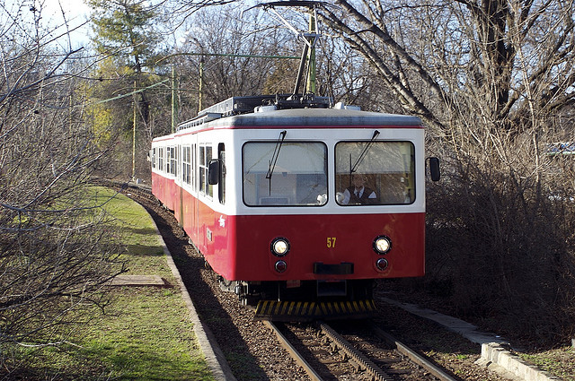
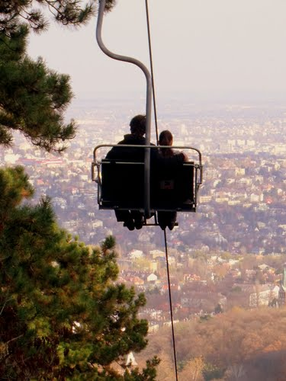
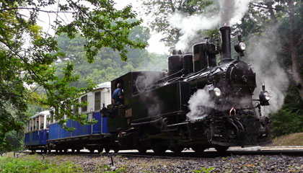
Budapest is surrounded by hills and forests. Another family friendly program is to have a day trip out to Liberty Mountain where you can take the cogwheel train up the steep mountain tracks which is a brilliant experience and then travel on the century old children’s steam train where the controllers are children. At the final destination you can take the chair lift down to the valley. Don’t forget your camera! You will take the most amazing photos!

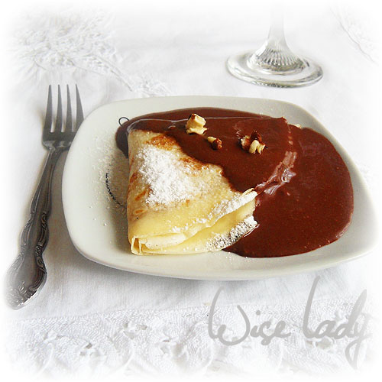
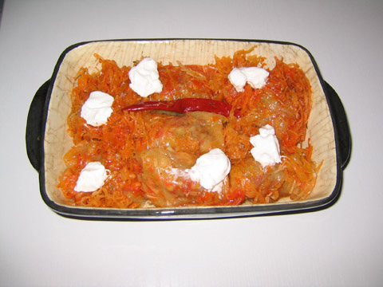
Are you hungry yet?
You must try traditional Hungarian food! Everyone’s favourite is stuffed cabbage with soft sour cream and the most famous delicious Hungarian bread! And what is for dessert? The brilliant and mouthwatering Gundel pancakes filled with walnut cream and soaked in chocolate custard. Best choice ever!

If you are ready for adventure then why not get on a plane and experience the fun?

