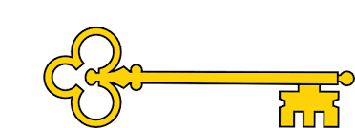

Learning objectives

 Predict : predict based on what’s been read so far

Predict : predict based on what’s been read so far

Vocabulary : find key information within the text

Infer : make inferences from the text

Sequence : sequence the key events in the story

Explain : explain key information about the main character

 Blurb and Main Themes

Lyra’s mama tells her she is an African princess, but Lyra is not so sure. Do real princesses live in the city and her freckles?

A wonderful story about a young girl finding out about her family. `

Links

Literacy

 Geography

 PSHE

Images

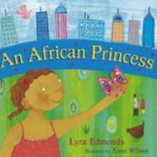 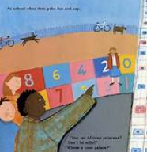

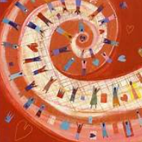

`

 Vocabulary

 Captured

Caribbean

Freckles

Savannah

Coconut

Canopy

Guava

Sapodilla tree

Africa

Reading Skills

V – Vocabulary

I - Inference

P – Prediction

E - Explain

R – Retrieval

S - Sequence

Fiction The African princess. Lyra Edmonds

Reading Skills

**Doors this will open…**

 Author

 Geographer

Year 1

Summer 2

**Next**Plants that bite back

Brain waves

**Previously**Armour

Usbourne readers

**Now**The African princess

Lyra Edmonds

Our Learning Keys