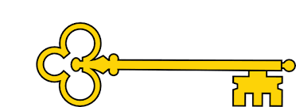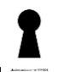

**Next...**

In Year 3 children will be introduced to millimetres and equivalent lengths. They will also learn about what a perimeter is and how to measure and calculate a perimeter.

Year 2

Measurement

Length + Height

**Previously…**

In Y1 children learnt to compare lengths and heights of objects as well as measure using both non-standard measures and cm.

**Questions**

What do the numbers on the ruler mean?

Where do you need to start measuring from?

How long/tall is the object?

What is “cm” short for?

How long is a metre stick?

What is “m” short for?

Which is longer, 1 cm or 1 m?

What does “/=” mean?

Do you need to add or subtract?

Do you need to multiply or divide?

**Vocabulary**

Length / Height

Measure

Centimetres / Metres

Longer than

Shorter than / Taller than

Shortest / tallest / longest

Is the same / equal to

Add / subtract

Multiply / Divide

Order / Compare

Measurement - Length + Height

Maths

**Links**

Science

**Images**

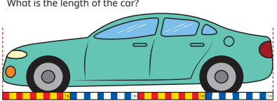 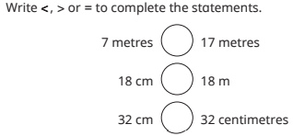

**Facts**

I can use a ruler to measure in centimetres

I can use metre sticks and tape measures to

measure in metres

I can compare length and height using the vocabulary of ‘longer than’,

‘taller than’ and ‘shorter than’

I can order height and length using the language of ‘shortest’, ‘tallest’

and ‘longest’

I can use the four operations to solve both one-step and two-step

problems relating to lengths and heights

Our Learning Keys

Year 2

Weeks 8-9

**Doors this will open…**

Builder

Architect

Carpenter

Engineer

Fashion designer

Tailor