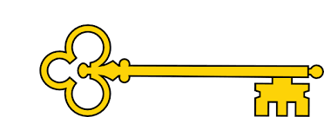

**Vocabulary**

Multiplication / multiply

Division / divide

Array

Groups of

Equal to

Times table

Double / halve

Odd / even

**Questions**

Are the groups equal or unequal?

Do all equal groups look the same?

How are 4 groups of 3 different from 3 groups of 4?

Can you write this as an addition sentence?

Is repeated addition always the most efficient method?

Which addition number sentence matches the multiplication?

Can you think of a story to match the multiplication?

What do the numbers represent?

How many rows / columns are there?

If you know what 5 × 2 is, how can you work out 6 × 2?

What does double / halve mean?

How could making/drawing an array help you?

**Previously…**

In Year 1 children learnt to count in 2’s, 5’s and 10’s. They made and added equal groups as well as arrays.

**Facts**

I can recognise equal groups

I can make equal groups

I can add equal groups

I can make the link between multiplication and repeated addition

I can use an array

I can divide by sharing

I know by two, ten and five times tables

I can divide by 2, 10 and 5

I can double and halve numbers

I can identify whether a whole number is odd or even

**Image**

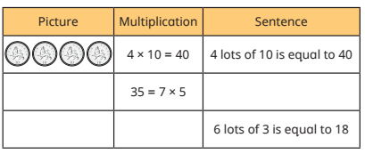  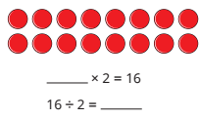

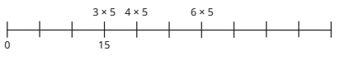

**Next...**

In Year 3 children will learn their 3, 4 and 8 times tables as well as how to divide by these numbers.

Year 2

Multiplication + Division

Our Learning Keys

Multiplication + Division

Year 2

Weeks 3-7

Maths

**Doors this will open…**

Banker

Data analysis

Statistician

Accountant

**Links**