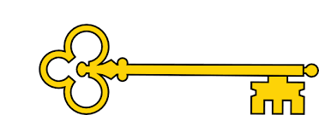

Measurement – Mass, Capacity + Temperature

**Questions**

What does heavier / lighter mean?

How do you use a balance scale?

What is mass?

How are circular scales different from balance scales?

Which is greater, a kilogram or a gram?

What is the difference between volume and capacity?

How could you find the capacity of this container?

Would you measure the capacity of this container in litres or millilitres?

What is temperature?

What does “°C” stand for?

**Vocabulary**

Mass

Volume / Capacity

Heavier / lighter

Balance scales / Circular scale

Litres / millilitres

Kilogram / gram

Thermometer / temperature

Degrees Celsius / °C

Hot / warm / cold

Year 2

Weeks 10 - 12

Year 2

Measurement

Mass, Capacity + Temperature

**Next...**

In Year 3 children will learn equivalent masses, capacity and volume and will add and subtract mass, capacity and volume.

Maths

**Links**

Food technology – weighing ingredients

Science – temperature / seasons

Geography – weather in different countries

**Images**

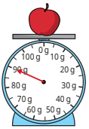 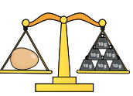 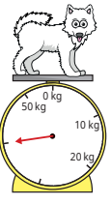 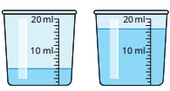 

**Previously…**

In Y1 children compared mass and measured using non-standard measures. They also compared volume and used non-standard measures to measure capacity.

**Facts**

I can compare mass

I can measure in grams and kilograms

I can use the four operations when calculating

mass

I can compare volume and capacity

I can measure in litres and millilitres

I can use the four operations when calculating volume and capacity

I can measure the temperature in degrees Celsius

Our Learning Keys

**Doors this will open…**

Scientist

Plumber

Crane operator

Personal Trainer

Doctor / Nurse

Baker / Chef

Weather forecaster