

**Facts**

I can count money in pence

I can count money in pounds

I can count money in pounds and pence

I can choose notes and coins to make a given amount

I can make the same amount in different ways

I can compare amounts of money using the

language of “greater than”, “less than”, “most” and “least”

I can find the total price of multiple items

I can find the difference in prices

I can make a pound

I can find change from £1

**Next...**

In Year 3 children will learn how to convert pounds and pence, add / subtract money and give change

Year 2

Money

**Previously…**

In Year 1 children learnt how to recognise coins and notes as well as count in coins

**Questions**

What are these coins / notes worth?

Which coin / note is worth more?

How much money is there altogether?

What is the total value of ­­__ £ __notes/coins?

What is the total value of ___p coins?

Can you find another way to make the same amount?

Does it matter if you count the pounds or pe*n*ce first?

What can you swap a £20 note for to keep the amount the same?

Which amount is the greatest/smallest?

**Vocabulary**

Money

Coin / note

Penny / pence (p)

Pound (£)

Worth / value

Greater / most / least

Difference

Our Learning Keys

Money

Year 2

Weeks 1-2

**Image**

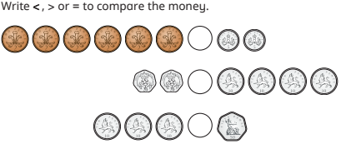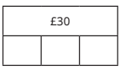 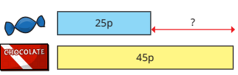

Maths

**Doors this will open…**

Banker

Shop keeper

Entrepreneur

Investor

Real estate agent

**Links**

PSHE – finance