

Learning objectives

 Predict what you think will happen based on the information that you have been given.

 Explain your preferences, thoughts and opinions about the text

 Make inferences from the text – how was the main character feeling?

 Draw upon knowledge of vocabulary in order to understand the text.

 Begin to understand alliteration

 Predict what you think will happen based on the information that you have been given

 Explain your preferences, thoughts and opinions about the text

 Sequence the key events in the story

 Blurb and Main Themes

It was supposed to be a present for Fudge’s dad. A little box from a jumble sale, just the sort of thing he loves.

No way was there supposed to be a Genie inside. A Genie who promises he can make all of Fudge’s wishes come true. Which does sound pretty cool.

But Fudge is about to find out that you have to be careful what you wish for. `

Links

  PSHE

Literacy

Images

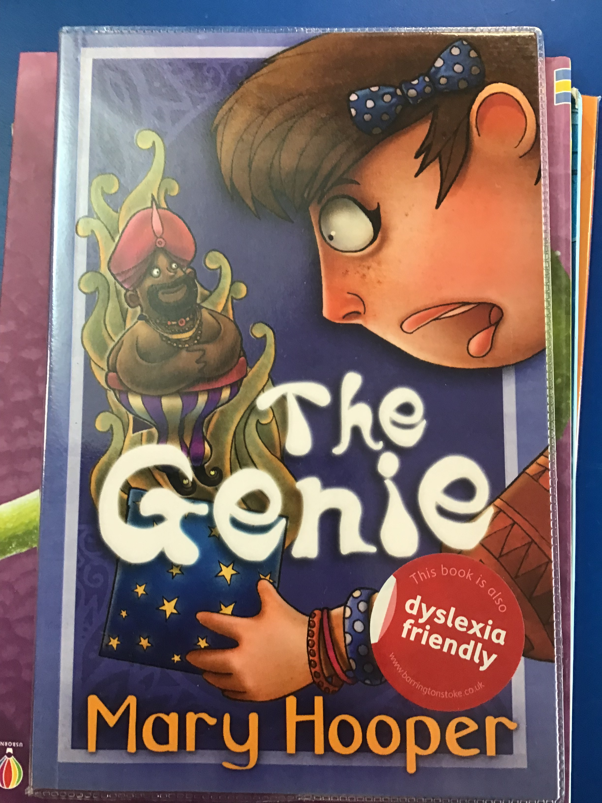 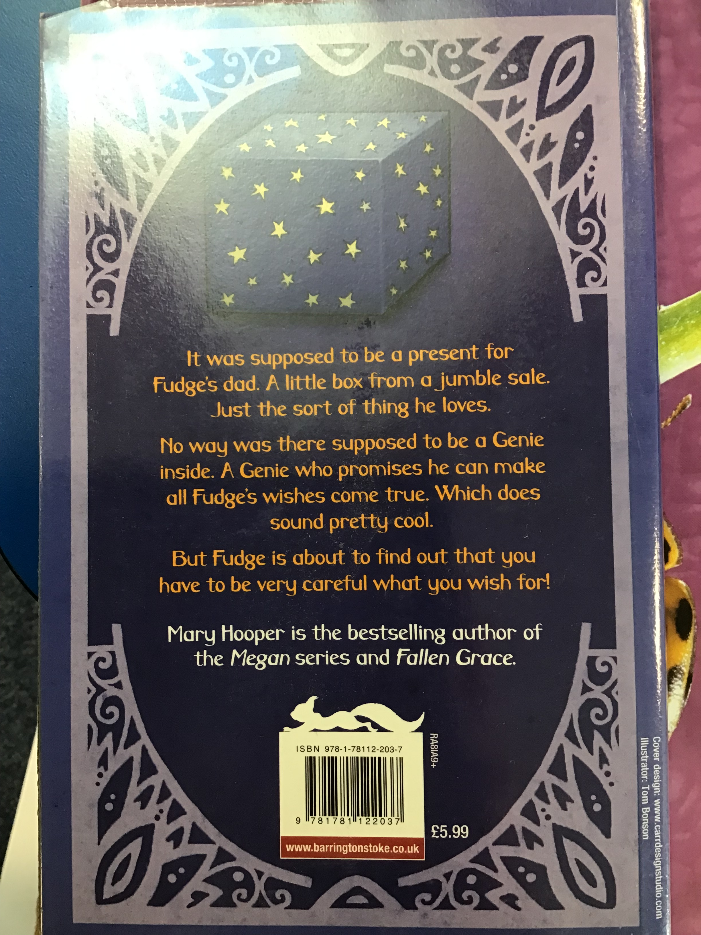

`

 Vocabulary

 Alliteration

Reading Skills

V – Vocabulary

I - Inference

P – Prediction

E - Explain

R – Retrieval

S - Sequence

Fiction. The Genie Mary Cooper

Reading Skills

**Doors this will open…**

 Author

Illustrator

Publisher

Year 1

Spring 1

**Next**

Lifeboat crew member

Here to help

**Previously**

I’m a little reindeer

Unknown author

**Now**

The Genie

Mary Hooper

Our Learning Keys