

Learning objectives

 Explain purpose of features

 Make inferences from text

 Use glossary to define new vocabulary

 Predict what happens next

 Sequence events from the text

 Explain your thoughts about the text

 Blurb and Main Themes

In Here to help- Lifeboat crew member, find out what it is like to rescue people at sea. Meet our volunteer lifeboat crew member, David, and some of the lifeboat crew he works with. Spend a day with him and see what happens in an emergency. Find out about the RNLI and their lifeboats and some of the training David does that helps him to do his job.

`

Links

 PSHE

Literacy

Geography

Images

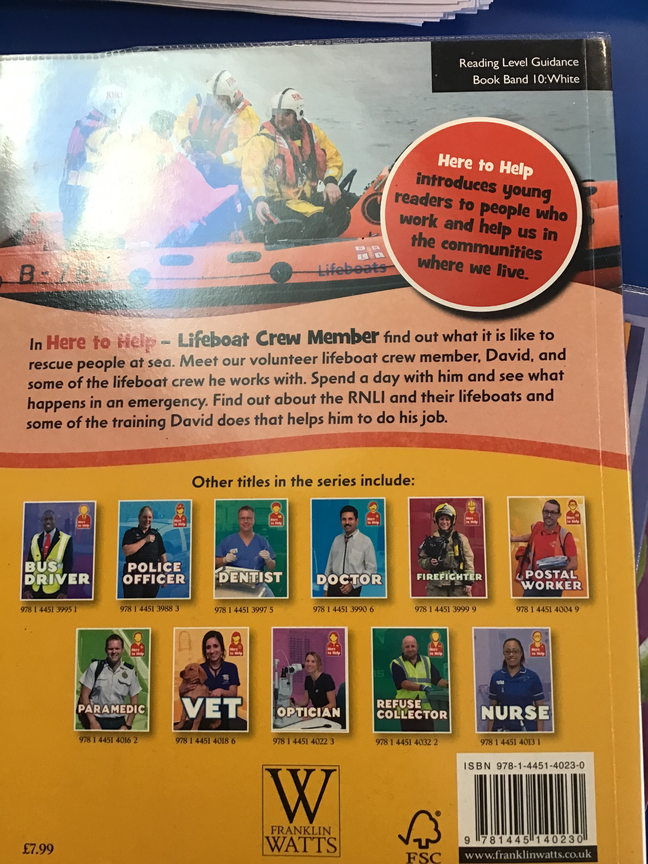

`

 Vocabulary

 Coastguard

 Capsize

 Volunteer

 RNLI

 Inshore lifeboats

 All weather lifeboats

Reading Skills

V – Vocabulary

I - Inference

P – Prediction

E - Explain

R – Retrieval

S - Sequence

Non-Fiction Lifeboat crew member. Here to help

Reading Skills

**Doors this will open…**

 Author

Volunteer worker

Army

Year 1

Spring 1

**Next**

Lifeboat crew member

Here to help

**Previously**

The Genie

Mary Hooper

**Now**

Lifeboat crew member

Here to help

Our Learning Keys