ESPAÑOL - SEGUNDO – TRIMESTRE DE VERANO - LOS ANIMALES – MASCOTAS
(Spanish - Year 2 – Summer Term – Animals – Pets)
Match the animals on the left with their names on the right by drawing lines (Use a ruler).
 |  | Rata
 |  | Gato
 |  | Serpiente
 |  | Pez
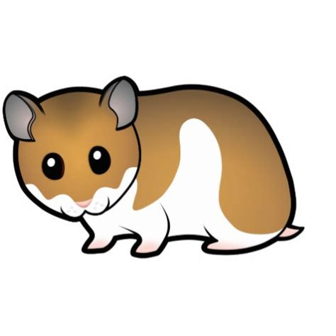 |  | Conejo
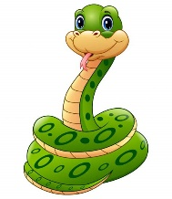 |  | Ratón
 |  | Hamster
 |  | Ave
 |  | Perro

