**How to play Strike Out**

**The aim of the game:**  
The player who stops their opponent from being able to go wins the game.  
   
  
**How to play:**

* Start by drawing a number line from 0 to 20 like this:

(You can find some of these number lines [here](https://nrich.maths.org/content/id/6589/Strike%20it%20Out%20Number%20Lines.doc).)



* The first player chooses a number on the line and crosses it out. The same player then chooses a second number and crosses that out too. Finally, he or she circles the sum or difference of the two numbers and writes down the calculation.

For example, the first player's go could look like this:  
  
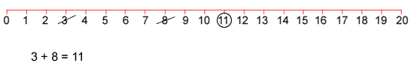

* The second player must start by crossing off the number that player 1 has just circled. He or she then chooses another number to cross out and then circles a third number which is the sum or difference of the two crossed-off numbers. Player 2 also writes down their calculation.

For example, once the second player has had a turn, the game could look like this:

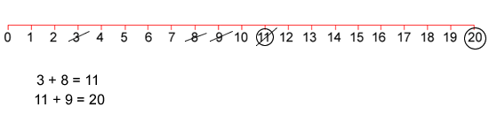

* Play continues in this way with each player starting with the number that has just been circled.
* Once a number has been used in a calculation, it cannot be used again.
* The game ends when one player cannot make a calculation. The other player is the winner.