**How to play Space Invaders**

**The aim of the game:**

The person who fills the largest area wins!  
   
**You will need:**

A coloured pen or pencil each.

Two dice.

A sheet of squared paper

**How to play:**

Start by choosing a coloured pencil or pen each.

Each player rolls one die – the highest number goes first.

The starting player rolls both dice (for example, the player rolls a 6 and a 4). They then draw a rectangle on the squared paper with these dimensions (6 squares by 4 squares) in their colour. They calculate the answer and write it in the middle (6 x 4 = 24).

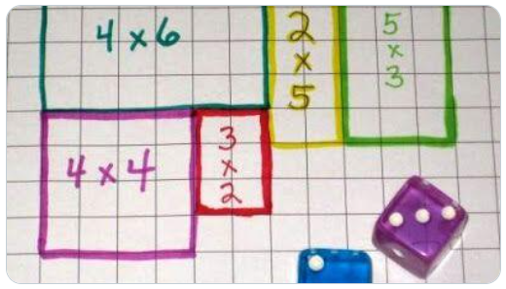

Add the total area of your shape too!

Credit: <https://twitter.com/shaunh0pper>

The second player now takes their turn, rolling both dice and adding a rectangle of their dimensions in their colour.

Special rule:

If a player cannot take their turn, as there is not enough space for their rectangle to fit, they miss their turn.

**End of the game:**

If the page is completely filled, or neither player can take their turn twice in a row, the game ends.

The player who controls more of the area of the page wins!

**Make it harder:**

Roll two six sided dice together to make a number up to 12, then repeat to make your calculation (this gives questions up to 12 x 12).

**Make it meaner!**

If a player calculates the area incorrectly, you steal their shape!

**Make it brighter!**

Use rainbow colours – just remember to write your name inside the shapes!