This is the second week of the maths overview. This week we are just focusing on length. If you have any questions please message either Miss Worsley or Mrs O’Reilly.
Week beginning: 20th April 2020
Monday 20th April
Starter to get our brains warmed up!  Positional language:  Can you place a teddy…  ON TOP OF something  NEXT TO something  IN BETWEEN something  UNDERNEATH something  Etc | The learning outcome we hope to achieve  Children should be able to compare lengths using reasoning and problem solving.  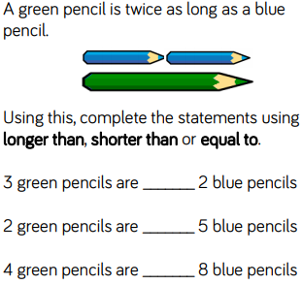 | Ideas for you to try at home  Select 2 items from around the house and compare their lengths.  Choose items which are very different in length and compared by looking at them before moving onto items which are similar in length and need to be measured.

Tuesday 21st April
Starter to get our brains warmed up!  Left and right  Jump to… THE LEFT  Hop to… THE RIGHT  Etc | The learning outcome we hope to achieve  Children order more than two lengths from shortest to longest and vice versa. This will help them recap their understanding of ordering numbers to 100 Children will order given lengths as well as ordering objects by measuring each length themselves. | Ideas for you to try at home  Choose 3 items from the house for the children to compare and measure – ensure they are using the correct vocabulary of: shorter, shortest, longer and longest to describe the order  Repeat with a different 3 items

Wednesday 22nd April
Starter to get our brains warmed up!  Turns  Remind children that a full turn is when we go all the way around and face the same way we started – we must always turn clockwise  Practice full turns starting in different places | The learning outcome we hope to achieve  Order lengths using reasoning and problem solving | Ideas for you to try at home  Four children are measuring their heights.  Eva is taller than Rosie, but not as tall as Mo. Dexter is taller than Mo.  Write down their names in order of their heights, starting with the shortest.

Thursday 2^{3rd} April
Starter to get our brains warmed up!  Turns  Remind children that a half turn is when we go half the way round and face the opposite way to which we started. Reminding them we always turn clockwise.  Practice half turns starting in different places | The learning outcome we hope to achieve  Order lengths using reasoning and problem solving | Ideas for you to try at home  Dora says:  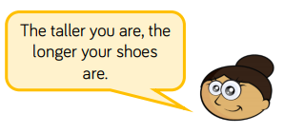  Measure the height of the people in your house and measure the length of their shoes.  Is Dora correct?

Friday 24th April
Starter to get our brains warmed up!  Turns  Remind children that a quarter turn is when we go all a quarter of the way to the right (looking at the face of a clock to support is really helpful)  Practice quarter turns starting in different places. If your child if confident then recap and practise three quarter turns as well. | The learning outcome we hope to achieve  Use problem solving and reasoning to solve worded length problems. | Ideas for you to try at home  There are 3 teddies in a box. The brown teddy is 15 cm taller than the yellow teddy. The yellow teddy is 3 cm shorter than the pink teddy. The pink teddy is 42 cm tall. How tall are the brown and yellow teddies? How much taller is the brown teddy than the pink teddy?

