For the next couple of weeks the Year 2 focus in Maths will be the unit Length and Height. Below are a few ideas of practical / written activities you may want to do with your child at home. This is the first week of the maths overview. If you have any questions please message either Miss Worsley or Mrs O’Reilly.
Week beginning: 30th March 2020
Monday 30th March
Starter to get our brains warmed up!  See how many star jumps you can do in 1 minute.  See how many burpees you can do in 30 seconds. | The learning outcome we hope to achieve  Children should be able to measure length and height to the nearest cm.  Children should be reminded to ensure they are measuring from 0 and not the end of the ruler or tape measure. | Ideas for you to try at home  Go around the house using a ruler or a tape measure. Measure items to the nearest cm.  Remember that length is from one side to the other and height is from top to bottom.

Tuesday 31st March
Starter to get our brains warmed up!  What can you do in only 30 seconds?  Can you write your name? Could you put your shoes on?  Children to the use a timer (or count to 30) to then challenge their grown up / sibling | The learning outcome we hope to achieve  Children should be able to draw different sized lengths and heights. | Ideas for you to try at home  Children to use a ruler or a tape measure to draw different sized lengths and heights.  E.g.  - draw a 4cm long line  - draw a line that is 10cm high  - draw a line that is longer than 4cm but shorter than 8cm in length.

Wednesday 1st April
Starter to get our brains warmed up!  Provide child with a selection of coins – can they name all 8 coins? | The learning outcome we hope to achieve  Children begin to measure larger objects using metres. They think about whether it is better to measure items in centimetres or metres and discuss the reasons why  Children do not yet convert from metres to centimetres; however they may see that 100 centimetres is the same as 1 metre and measurements can be written as mixed units e.g. the child is 1 metre and 25 centimetres tall. | Ideas for you to try at home  Create a list of items which are bigger than 1 metre.  Create a list of items which are smaller than 1 metre.  If children would like a challenge:  Measure the length of your front room. Record in metres and centre metres.

Thursday 2nd April

Starter to get our brains warmed up!  Provide children with a selection of coins – can they add the coins together to give you a total? | The learning outcome we hope to achieve  Children compare lengths of objects using comparison language and symbols. They use language such as longer than, shorter than, taller than, longest, shortest and tallest. Children only compare using the same unit of length in a question. However, the same number but different unit of measure could also be used to check that children understand metres are bigger than centimetres. | Ideas for you to try at home  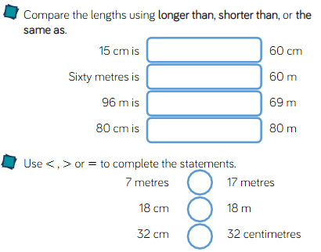

Friday 3rd April
Starter to get our brains warmed up!  Provide children with a selection of coins – once children have found the total – take away a coin – can they find the new total | The learning outcome we hope to achieve  Children to use problem solving to compare lengths. | Ideas for you to try at home 