

**Shine week**

**13th – 17th July**

**2020**

**Make a Musical Instrument**

**Why not make your own musical instrument to entertain your family and friends with? There are four different families of instruments which make noise in different ways.**

|  |  |
| --- | --- |
| **String instruments – these can be plucked, strummed or bowed. The sound is made when the string is made to vibrate.** | **Wind instruments – These are made of metal or wood and you blow down them. Making the tube longer creates a low pitch and making the tube shorter creates a higher pitch.** |
| **Brass Instruments – These are made of brass and are blown. By pressing buttons, valves open and close and create higher and lower pitched notes.** | **Percussion Instruments – These are instruments that are hit with your hand, drum sticks or beaters or shaken.** |

**You can have a go at creating your own musical instruments using junk and things you can find around the house.**

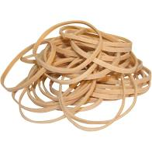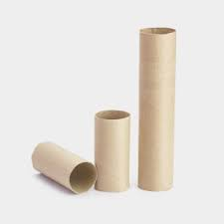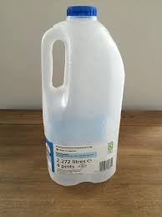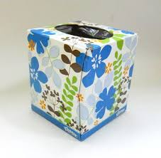

**Here are a few examples of the types of things you might have lying around that might be useful.**

**Follow the links below for ideas, inspiration and instructions on how to make your own instruments.**

<https://www.activityvillage.co.uk/musical-instruments>

<https://www.youtube.com/watch?v=pFfBrCyHfWs>

**You can either have a go at creating one of these or use your knowledge of how instruments work to create your own. You are all so inventive that you are bound to come up with something great.**

**Have fun**

