

SAVE THE EARTH

RECYCLE

DON’T LITTER

Every day the Earth is being damaged by dangerous, toxic fumes which slowly fill the air with poisons.

EARTH DAY 2020

If you recycle as much as you can then less pollution will be released into the environment by factories.

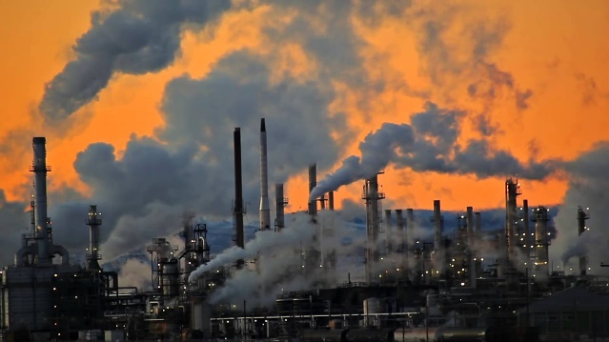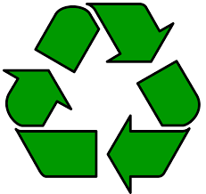

When rubbish is carelessly thrown on the ground, poor innocent animals can die as a result!