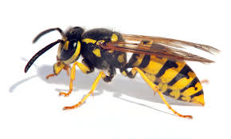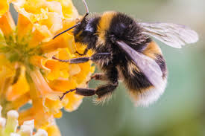

EARTH DAY 2020

Bees are fascinating and important insects.

If we didn’t have bees, then our flowers and crops wouldn’t get pollinated.

Bees and wasps help our food crops to grow. Without them, we would all go hungry!

Plant them flowers in YOUR garden to say thank you!

When your garden is filled with flowers; bees, wasps and other insects can feed on the sweet, delicious nectar and at the same time spread pollen.

PROTECT THE BEES

SAVE OUR FOOD