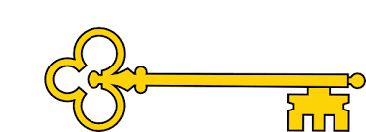

 Handwriting

Week 1- ing, er, playing, teacher

Week 2- jumped, coldest, buses, unhappy, words.

`

Phonics

|  |  |  |  |  |
| --- | --- | --- | --- | --- |
|  | **Focus** | **Decodable Words** | **Common Exception Words (Reading)** | **Common Exception Words (Writing)** |
| **Week 1** | Adding -ing and -er | Playing, player, teaching, teacher | Brought and favourite | More and before |
| **Week 2** | Phonics screening week |  |  |  |
|  |  |  |  |  |

Year 1

Summer 2

Images

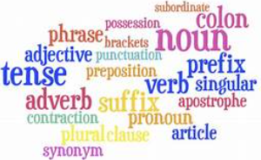

`

Features

SPaG is an abbreviation for spelling, punctuation and grammar.

The primary curriculum expects children to be taught how to spell, use punctuation and how words are put together to form proper sentences.

**Doors this will open…**

Author

Teacher

Links

 Reading- Understanding features of a text.

 Vocabulary

Suffix

Prefix

Full stop

Question mark

Exclamation mark

**Next**Fiction

Warning tale

The Magic Paintbrush

**Previously**

Non-Fiction

Explanation

**The life cycle of a chick**

**Now**SPAG

-ing, -ed, -er, -est, -s, -es, Un, Full stop, question mark and exclamation mark

Literacy

Our Learning Keys

Spelling, Punctuation, and, Grammer