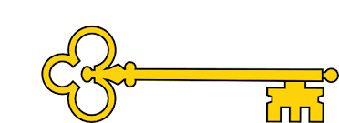

Year 1

Spring 2a

 Handwriting

Week 1: F G H I J

Week 2: K L M N O

Week 3: P Q R S T

`

Phonics

|  |  |  |  |  |
| --- | --- | --- | --- | --- |
|  | **Focus** | **Decodable Words** | **Common Exception Words (Reading)** | **Common Exception Words (Writing)** |
| **Week 1** | ‘y’ saying /ee/ | very, family, body, happy, sunny, furry, crunchy, hairy | any, eye | water, where |
| **Week 2** | ‘aw’ and ‘au’ saying /or/ | saw, paw, draw, yawn, August, launch, laundry, astronaut | friend, also | who, why |
| **Week 3** | ‘ow’ and ‘oe’ saying /oa/ | low, slow, window, own, toe, hoe, doe, goes | once, please | thought, through |

Images

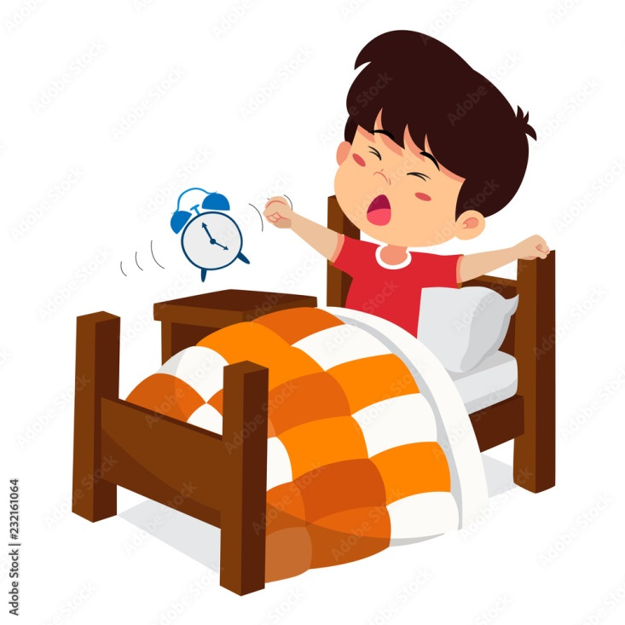 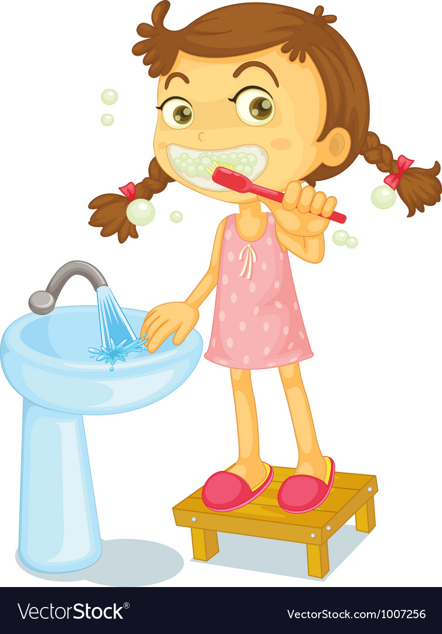

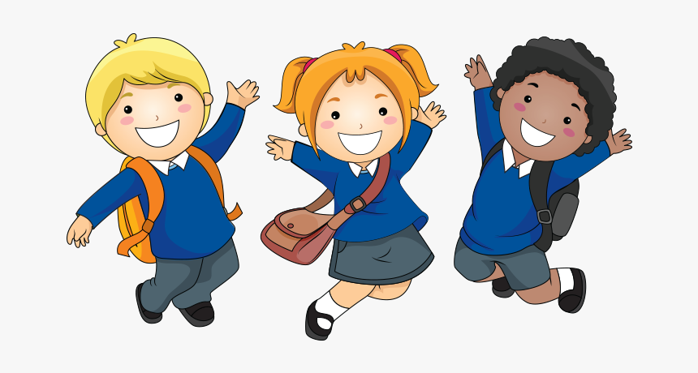

`

Text Type Features

 **Opening** - describes When? Who? What? Where?

  **Middle section -** expands opening and describe events

  **Conclusion -** round it off and explain how it felt.

  Chronological Order

  First person pronouns **–** I, me, we, us

 Past Tense verbs

 Time conjunctions

**Doors this will open…**

Author

Diary Writer

Journalist

Biographer

Links

 History– events in living memory

 PSHE – daily routines.

 Vocabulary

Chronological

Past Tense

This morning

First

Then

Next

After that

Lastly

Finally

**Next**Fiction

Finding Tale

The Story of Pirate Tom

**Previously**Non - Fiction

Non-Chronological Report

Dolphins

**Now**Non- Fiction

Recount

My Morning

Literacy

Our Learning Keys

Non- Fiction My Morning Recount