

 Handwriting

Week 1: apple back vans stars rest

Week 2: ever fox zoo oxen fuzzy

Week 3: A B C D E

`

Phonics

|  |  |  |  |  |
| --- | --- | --- | --- | --- |
|  | **Focus** | **Decodable Words** | **Common Exception Words (Reading)** | **Common Exception Words (Writing)** |
| **Week 1** | ‘ir’ saying /ur/ | stir, girl, bird, shirt, dirt, third, first, thirteen | work, house | love, your |
| **Week 2** | ‘ue’ saying /oo/ and /yoo/ | due, venue, fuel, argue, clue, glue, true, blue | many, laughed | people, looked |
| **Week 3** | ‘ew’ saying /oo/ and /yoo/ | few, new, dew, stew, blew, chew, grew, drew | because, different | asked, called |

Year 1

Spring 1b

Images

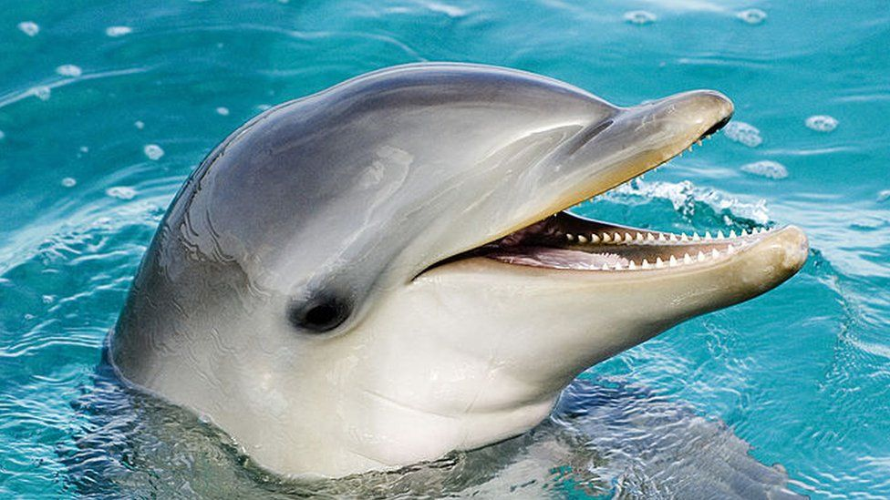 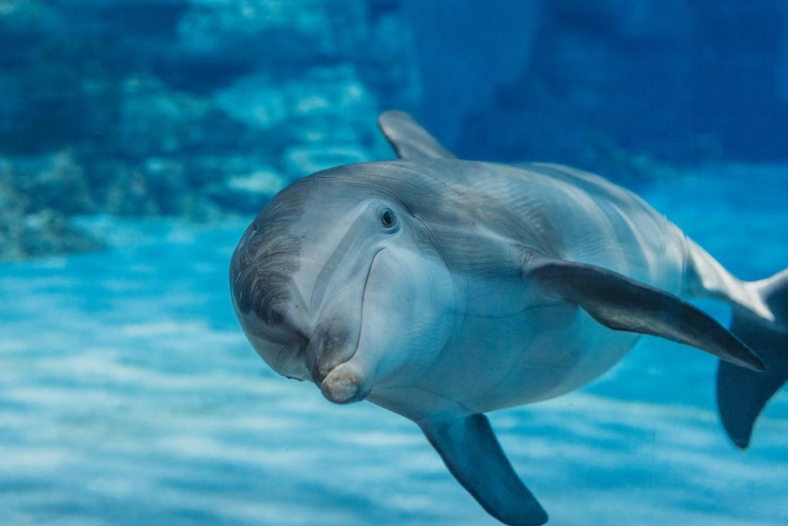

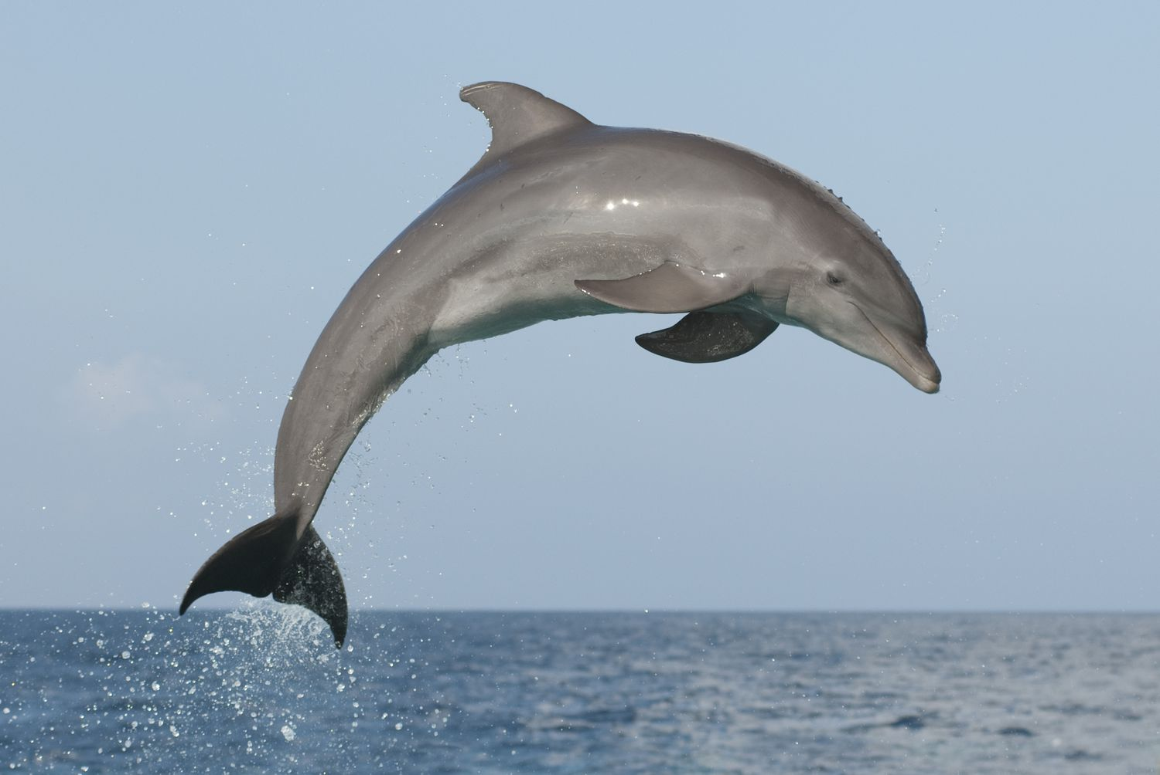 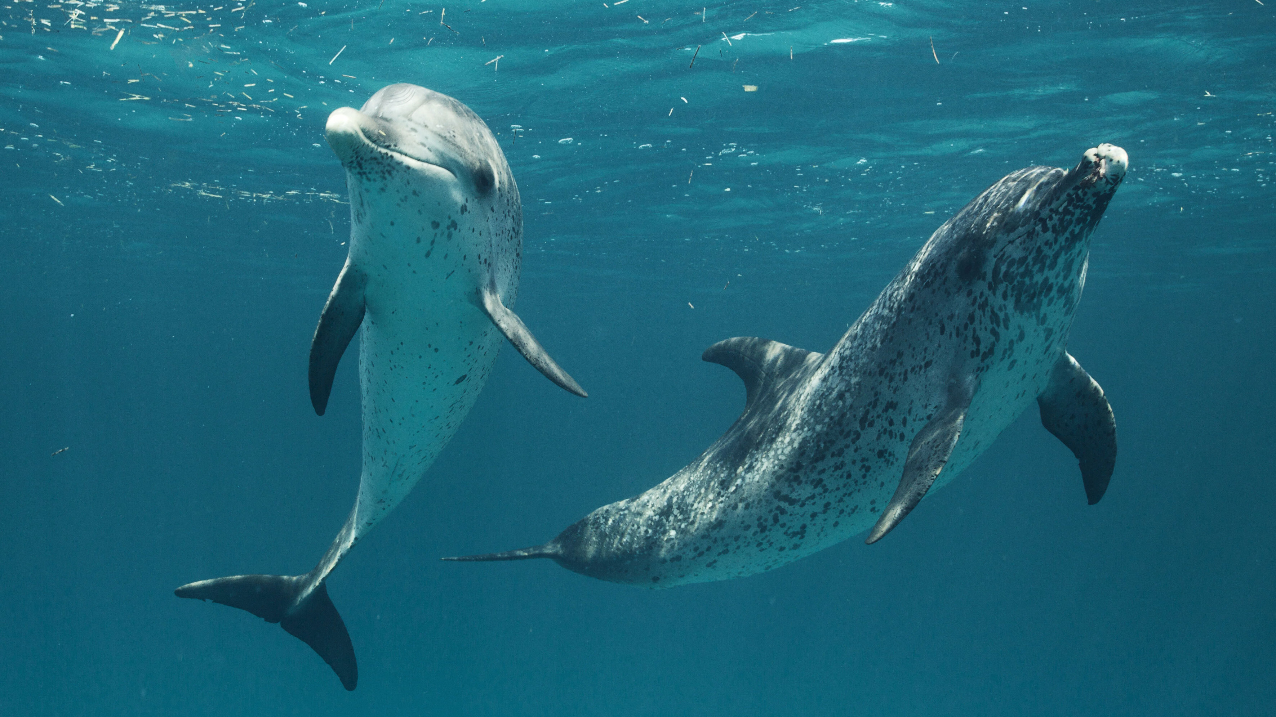

`

Text Type Features

 **Heading** – what the Non-chronological report is about

  **Introduction** – introduces reader to the topic

  **Middle section** – facts about the topic

  **Subheadings** - what the following paragraph is about

  **Conclusion** – finishing the text with an interesting fact.

**Doors this will open…**

Author

Explorer

Diver

Marine Biologist

Links

 Science– living animals

Geography - Oceans

 Vocabulary

Non - Fiction

Facts

Magical

Fins

Flippers

Shallow

Carnivores

Oceans

Rivers

**Next**Non- Fiction

Recount

My Morning

**Previously**Fiction

Journey Tale

Handa’s Surprise

**Now**Non - Fiction

Non-Chronological Report

Dolphins

Literacy

Our Learning Keys

Non- Fiction Dolphins Non-Chronological Report