

 Handwriting

Week 1: toad data ham mend them

Week 2: yell eye jaw jay huge

Week 3: going quay queen bap kept

`

Phonics

|  |  |  |  |  |
| --- | --- | --- | --- | --- |
|  | **Focus** | **Decodable Words** | **Common Exception Words (Reading)** | **Common Exception Words (Writing)** |
| **Week 1** | ou’ saying /ow/ | our, about, cloud, scout, sprout, proud, sound, ground | water, where | should, would |
| **Week 2** | Long Vowel Sounds | apricot, kind, wild, lion, human, gold, hotel, both | who, why | want, their |
| **Week 3** | Assessment Week | Recapping previously taught GPC | Recapping previous common exception words | Recapping previous common exception words |

Year 1

Spring 1a

Images

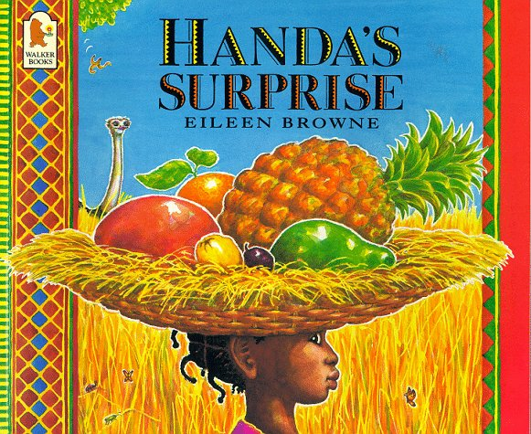 

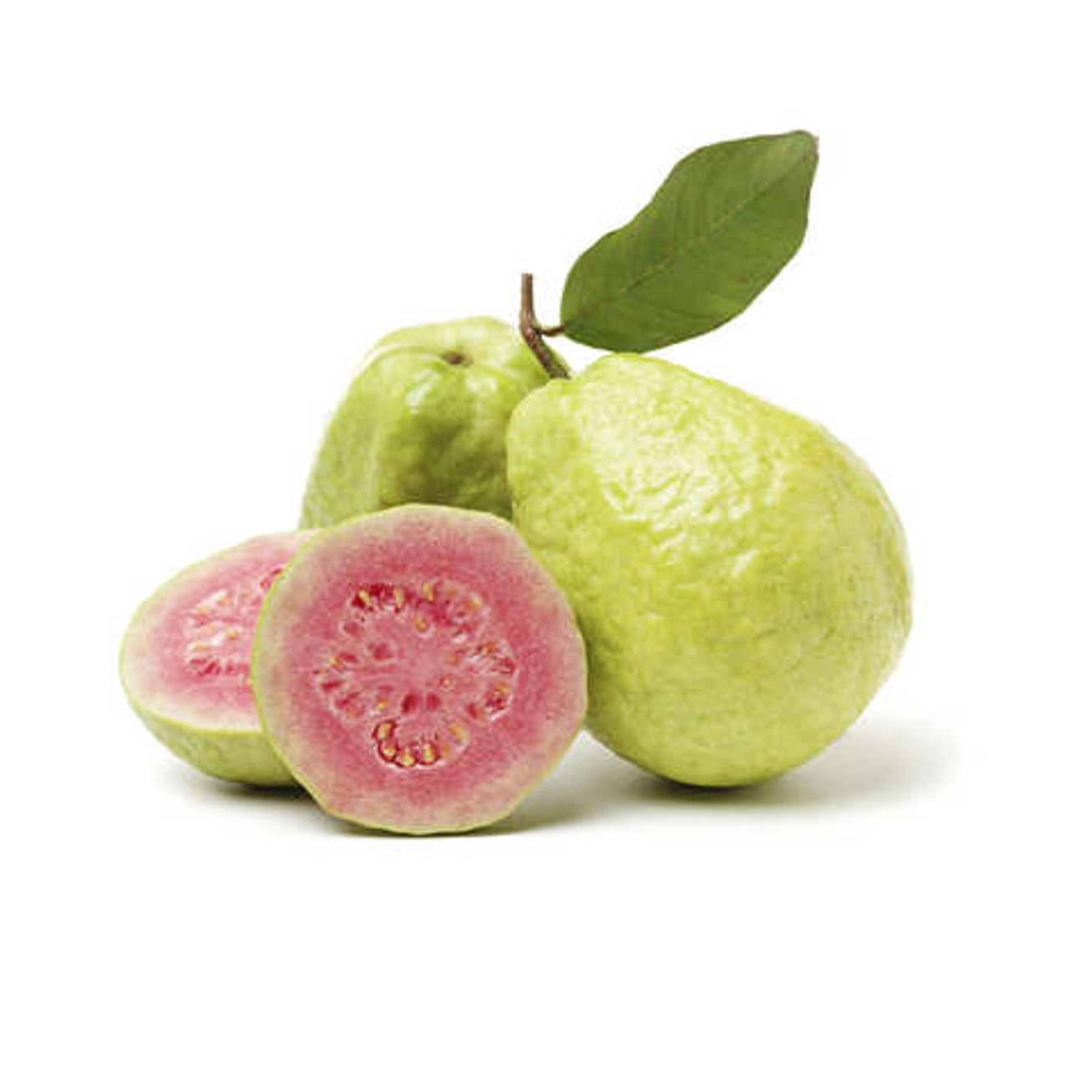 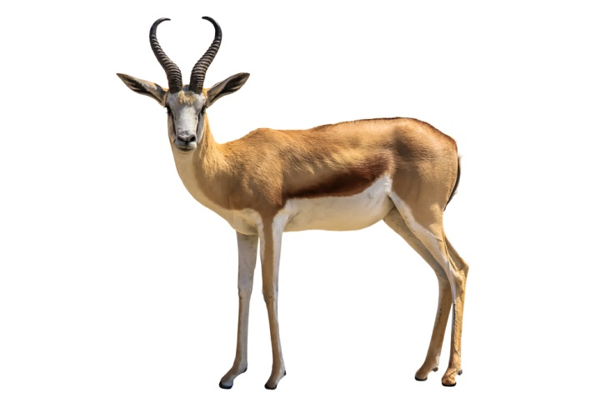

`

Text Type Features

 Character goes on a journey from *a* to *b and along the way t*hey have to overcome various hurdles.

**Narrative Features:**

 Introduction

  Build Up

 Problem

 Resolution

 Ending

 More than one Problem and Resolution

**Doors this will open…**

Author

Story-Teller

Traveller

Safari Guide

Links

 PSHE – relationships

Geography – different countries and cultures

 Science– animals

 Vocabulary

surprised

village

guava

antelope

tangy

tangerine

charged

unfortunately

finally

**Next**Non-Fiction

Non – Chronological Report

Dolphins

**Previously**Non-Fiction

Instructions

How to Catch a Wolf

Pharaoh

**Now**Fiction

Journey Tale - Narrative

Handa’s Surprise

Literacy

Our Learning Keys

Fiction Handa’s Suprise Journey Tale