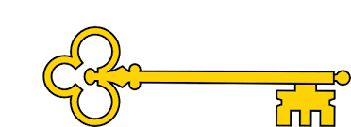

Phonics

|  |  |  |  |  |
| --- | --- | --- | --- | --- |
|  | **Focus** | **Decodable Words** | **Common Exception Words (Reading)** | **Common Exception Words (Writing)** |
| **Week 1** | a_e’ saying /ai/ | game, name, snake, cake, came, make, same, ate | love, your | little, one |
| **Week 2** | ‘i_e’ saying /igh/  ‘o_e’ saying /oa/ | bike, time, pine, prize, bone, home, note, alone | people, looked | do, when |
| **Week 3** | ‘u_e’ saying /yoo/  ‘e_e’ saying /ee/ | use, cube, fume, tube, these, theme, even, complete | called, asked | what, could |
| **Week 4** | ‘ch’ saying /c/ and /sh/ | school, Christmas, chemist, chord, echo, chef, parachute, chute | thought, through | Mr, Mrs |

Literacy

 Handwriting

Week 1: ui ill it lit tilt

Week 2: we wet wilt lute cow

Week 3: owe ice coil lad add

Week 4: toad data ham mend hand

`

Year 1

Autumn 2b

Images

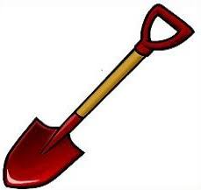 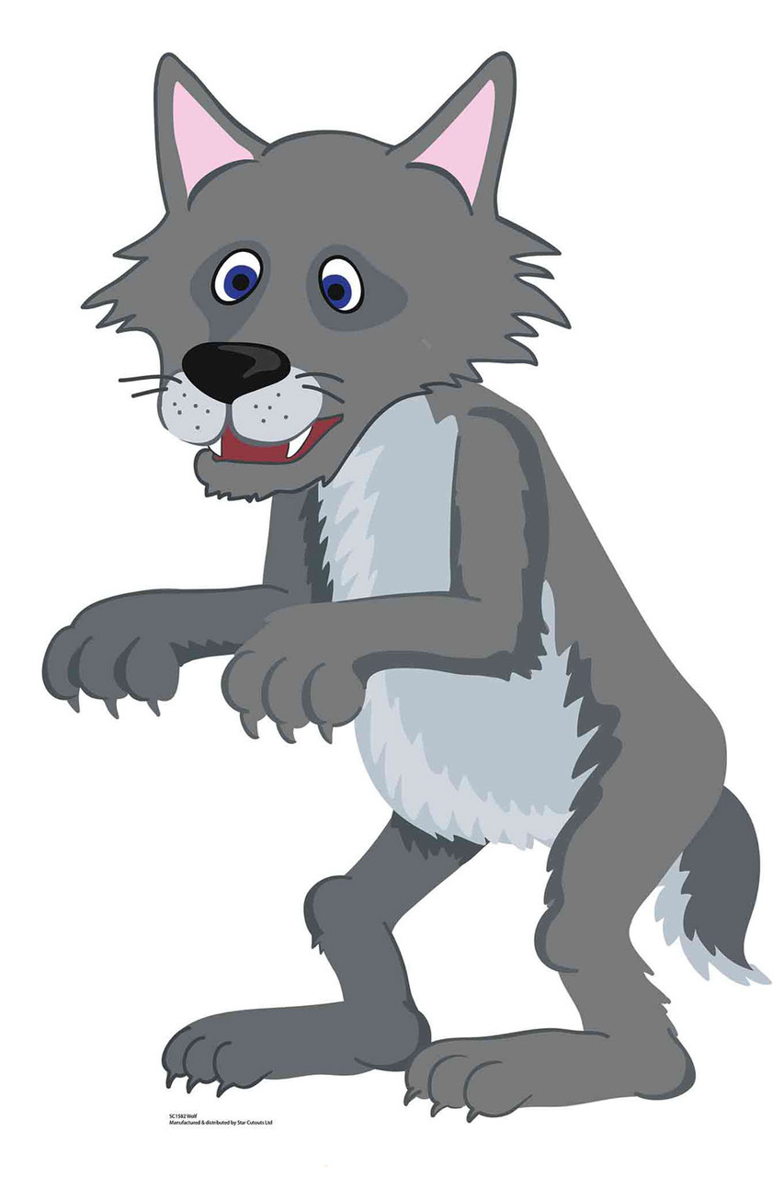

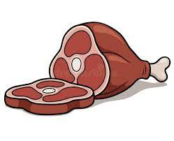 

`

Text Type Features

 Title – what the instructions are for

  What you need – materials

  What you do - numbered steps

 Chronological order

 Commas in a list

  Imperative verbs.

 Time conjunctions

**Doors this will open…**

Author

Teacher

Builder

Zoologist

Architect

Links

 DT – design and make own wolf trap

 PSHE –Life choices

 Vocabulary

Instructions

Imperative verbs

Chronological order

Time conjunctions

Deep

Cover

Scatter

Tiptoe  
Resist

Temptation

**Next**Fiction

Journey Tale - Narrative

Handa’s Surprise

**Previously**Fiction

Defeating the Monster

The Three Little Pigs

Pharaoh

**Now**Non- Fiction

Instructions

How to Catch a Wolf

Our Learning Keys

Non- Fiction How to Trap a Wolf Instructions