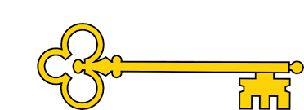

 Handwriting

Week 1: g q b p k

Week 2: v s r f z

Week 3: x vo wo

ru wa

`

Phonics

|  |  |  |  |  |
| --- | --- | --- | --- | --- |
|  | **Focus** | **Decodable Words** | **Common Exception Words (Reading)** | **Common Exception Words (Writing)** |
| **Week 1** | CCC Words | crisps, screen, shred, splat, plants, splash, throb, street, three, moths | do, when, out, what | my, here |
| **Week 2** | Polysyllabic words | desktop, sandwich, lunchbox, handstand, windmill, melting | Revision of taught words | Revision of taught words |
| **Week 3** | ‘ay’ saying /ai/ | day, may, say, play, clay, tray, spray, crayon | could, should | said, so |

Year 1

Autumn 1b

Images

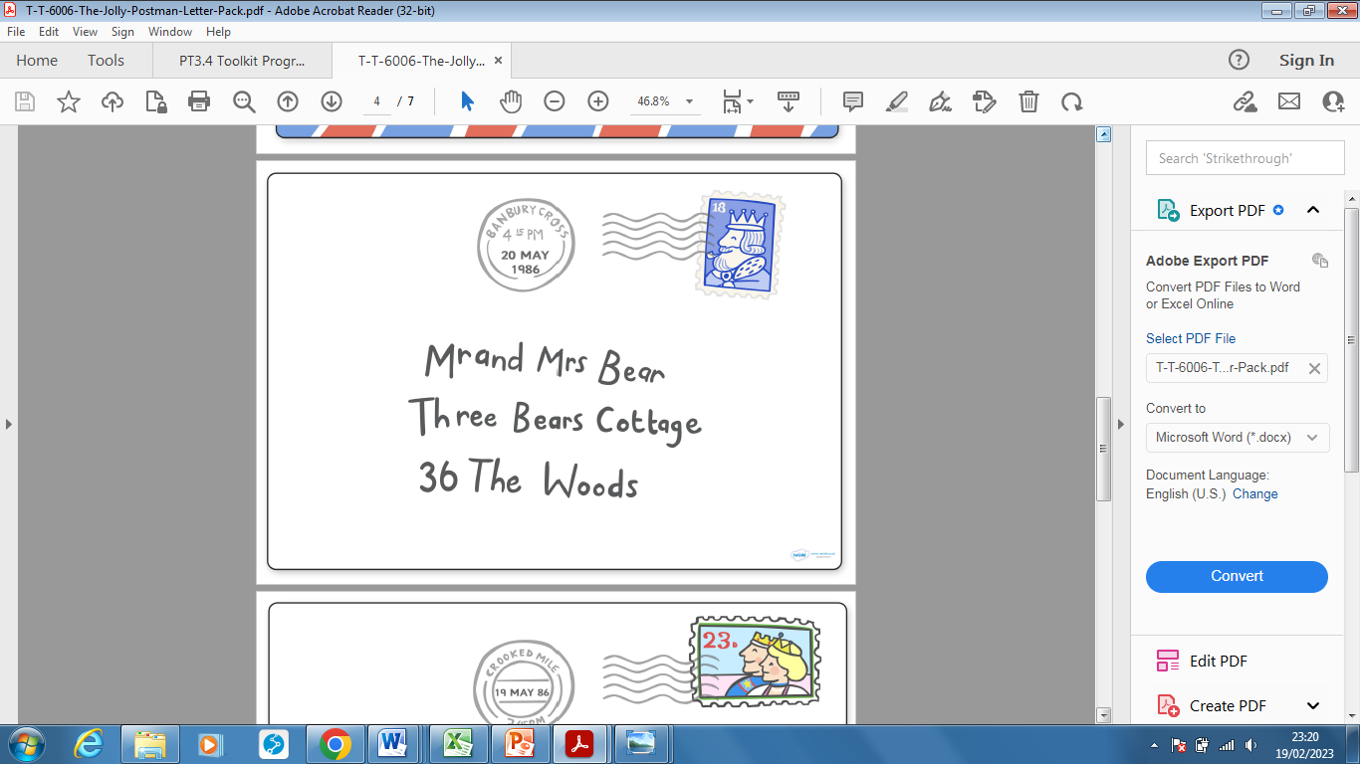 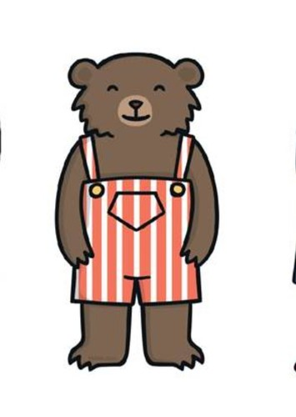

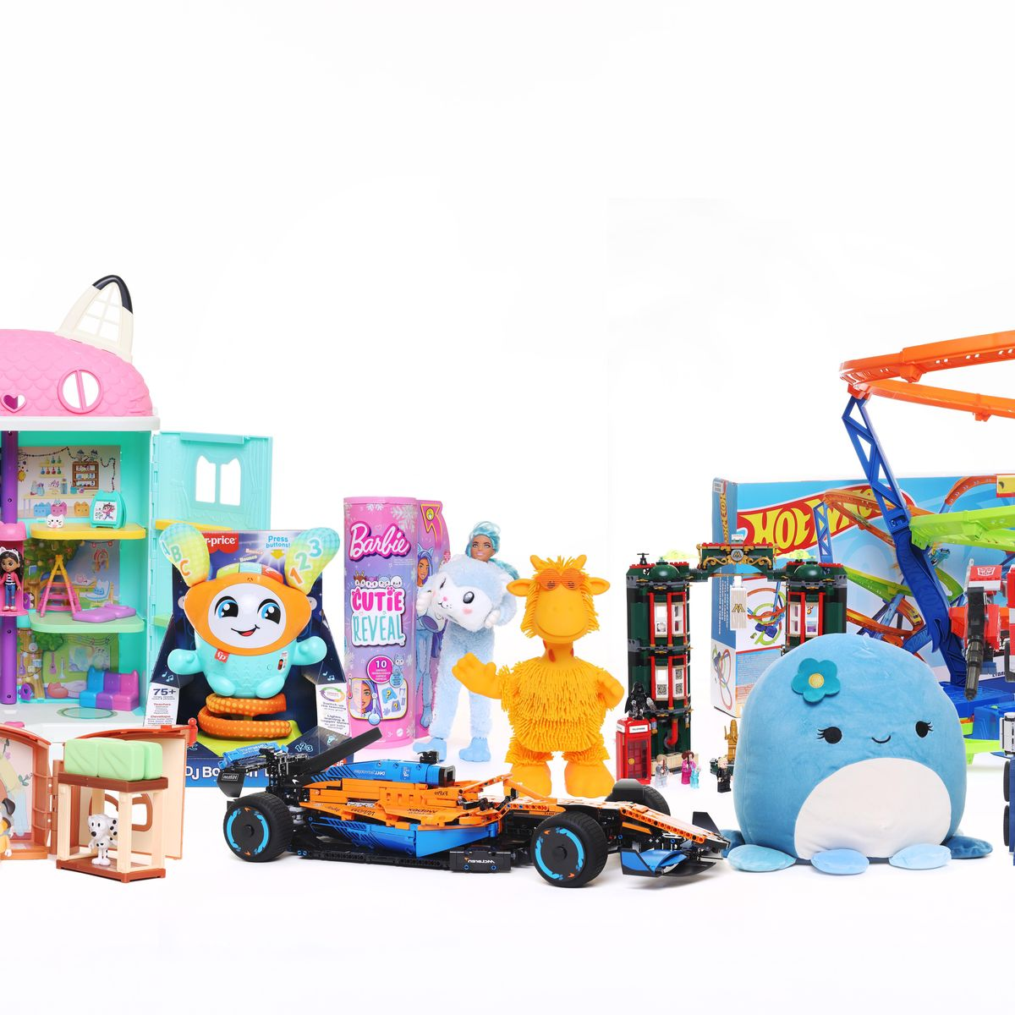 `

Text Type Features

 Letter features:

* **Dear** – who the letter is for
* **Purpose** – why the letter is being written
* **From** – who has written the letter

 Persuasive Writing features:

* **Opening sentence** - What the text is trying to persuade the reader to do.
* **Positive points** – three positive things that will persuade the reader.
* **Conclusion** – a summary of the points.

 

**Doors this will open…**

Author

Story-Teller

Postal   
delivery worker

Letter writer

Links

 PSHE – behaviour

 PSHE - relationships

 Vocabulary

Dear

From

Firstly

Secondly

Thirdly

Exciting

delicious

please

**Next**Fiction

Defeating The Monster

The Three Little Pigs

**Previously**Fiction

Warning Tale

Little Red Riding Hood

**Now**Non-Fiction

Letter/Persuasion

Wolf Friendship Letter

Literacy

Our Learning Keys

Non-Fiction Baby Bear Friendship Letter Persuasive Writing