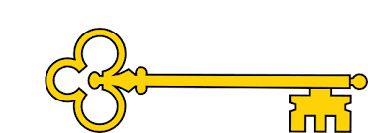

Phonics

|  |  |  |  |  |
| --- | --- | --- | --- | --- |
|  | **Focus** | **Decodable Words** | **Common Exception Words (Reading)** | **Common Exception Words (Writing)** |
| **Week 1** | CVCC Words | mist, tusk, hand, rust, gift, belt, wept, bump, fact, self, went, sink | said, so | he, she, me,  we, be |
| **Week 2** | CCVC Words | swing, train, frog, slot, blog, grip, plan, crib, drag, flex, glad, twin | have, like,  come, some | was, you |
| **Week 3** | CCVCC Words | crisp, twist, trunk, frost, plant, stamp, skunk, spend, blast, drink | were, there,  little, one | they, are, all |

 Handwriting

Week 1: i l t u w

Week 2: e c o a d

Week 3: n m h j y

`

Year 1

Autumn 1a

Images

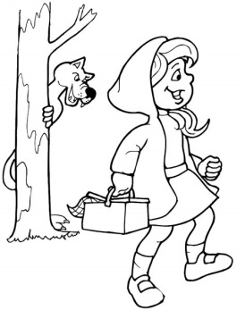 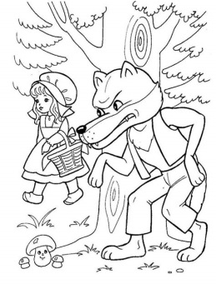

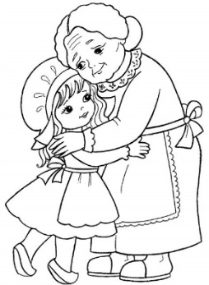 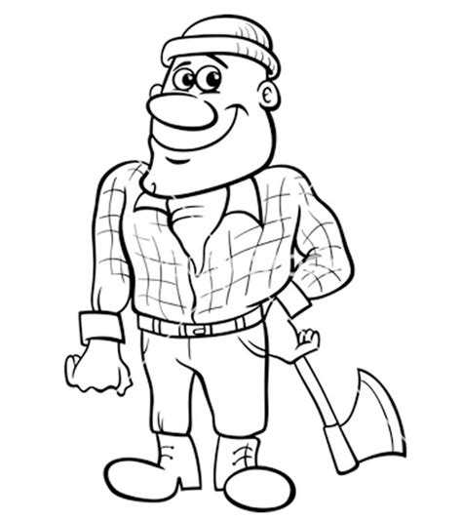

Text Type Features

 Main character warned not to do something, does it anyway and gets into trouble.

**Narrative Features:**

 **Introduction** – introduces characters and setting.

 **Build Up** – what the characters are doing.

** Problem** – something that goes wrong.

 **Resolution** – how the problem is solved

 **Ending** – what the characters do at the end

 

**Doors this will open…**

Author

Story-Teller

Woodcutter

Links

 PSHE – behaviour

 PSHE – relationships

Science – signs of autumn

 Vocabulary

Once upon a time

One day

Suddenly

Luckily

Finally

Character

Villain

Hero

**Next**Non-Fiction

Letter/Persuasion

Wolf Friendship Letter

**Previously**

**Now**Fiction

Warning Tale

Little Red Riding Hood

Literacy

Our Learning Keys

Fiction Little Red Riding Hood Warning Tale