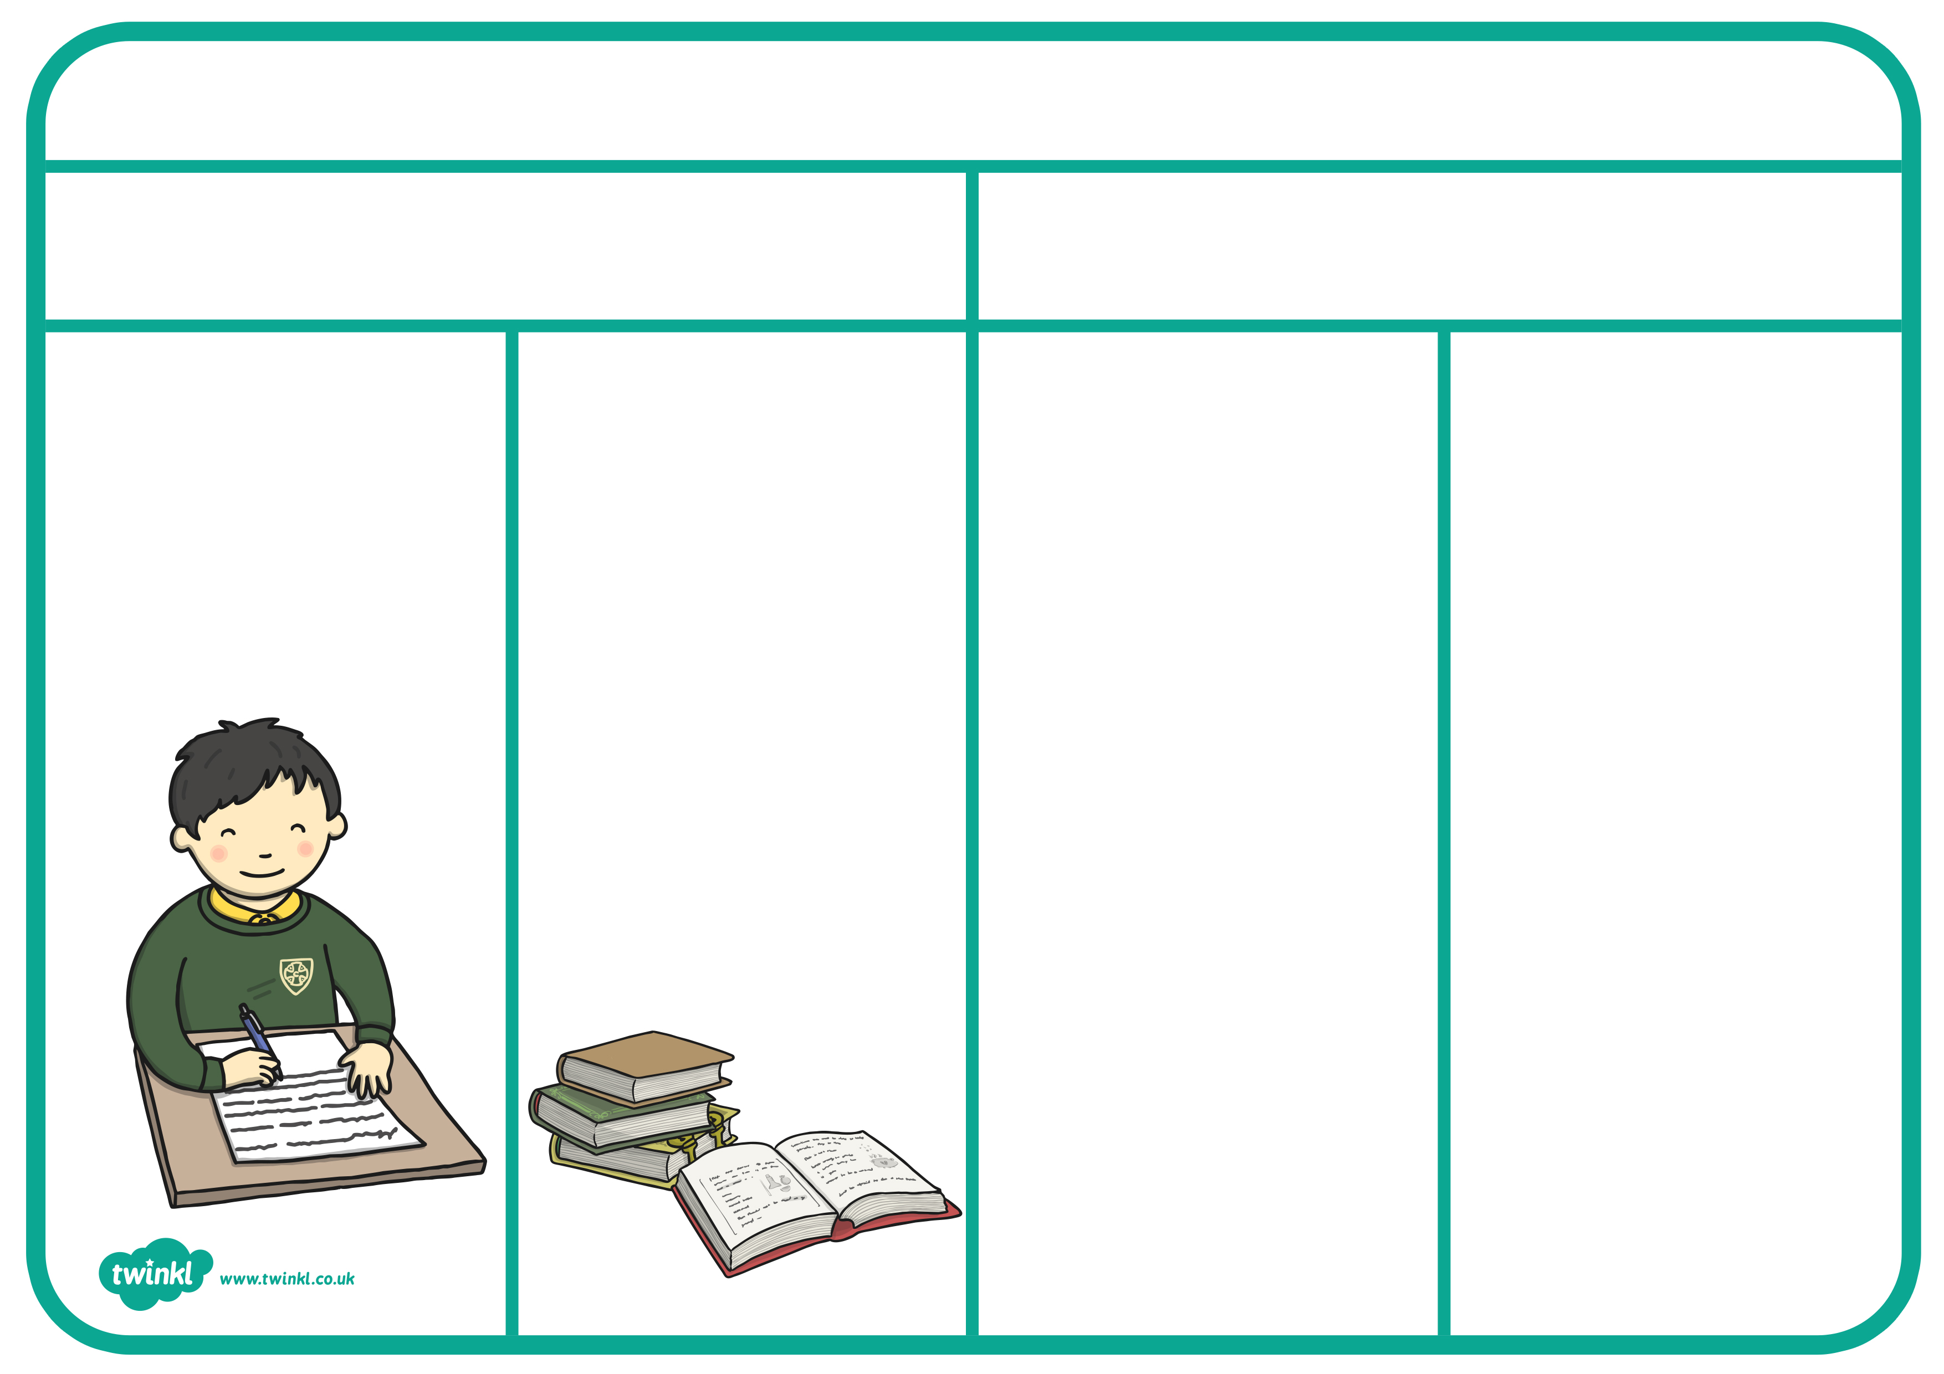
These link two words or phrases together as an equal pair.
Subordinating conjunctions
Conjunctions
Conjunctions link two words or phrases together
Coordinating conjunctions
Year 1
and
These introduce a subordinate clause.
for
nor
but
or
yet
so

when
if
that
because
after
as
before
once
provided
since
though
till
unless
until
whenever
wherever
whether
while
plus:
Year 2
plus:
when
if
because
although
Year 3/4

