Literacy
Your task is to write your own short story describing the animal’s habitat.

- What do we call describing words?
- Can you use the power of three?
- Can you include all five senses in your description?
- Have you checked your work for full stops and capital letters?
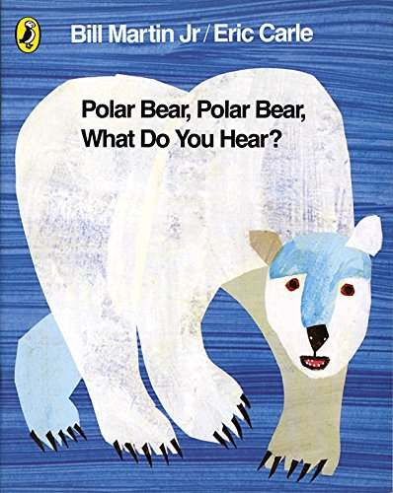
Geography
Your task use the places provided to map the route of the Titanic

- Where did the Titanic set sail from?
- Where was the first destination?
- How many stops are there in total?
- Where was the Titanic supposed to end up?

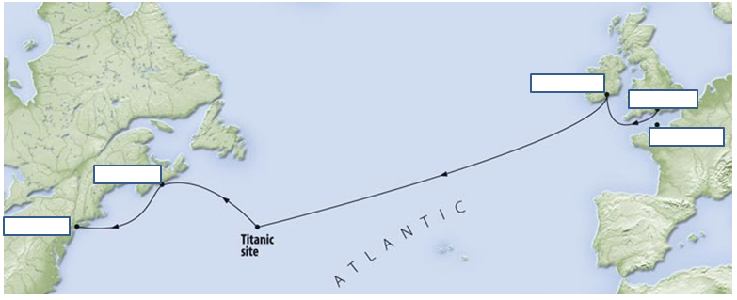
History
Your task is to discuss the timeline of the Titanic with a partner.

- How many people are on board?
- Where has the Titanic set sail from?
- Where was the Titanic built?
- What time did water start to pour in?
- How do you think the passengers would be feeling when the water started to pour in?
- How would you feel if you saw an iceberg?
Art
Your task is to paint your papier mache dragon egg.

- What resources do you need?
- What pattern will you use?
- What colour is a dragon egg?
- How many layers are you going to do?
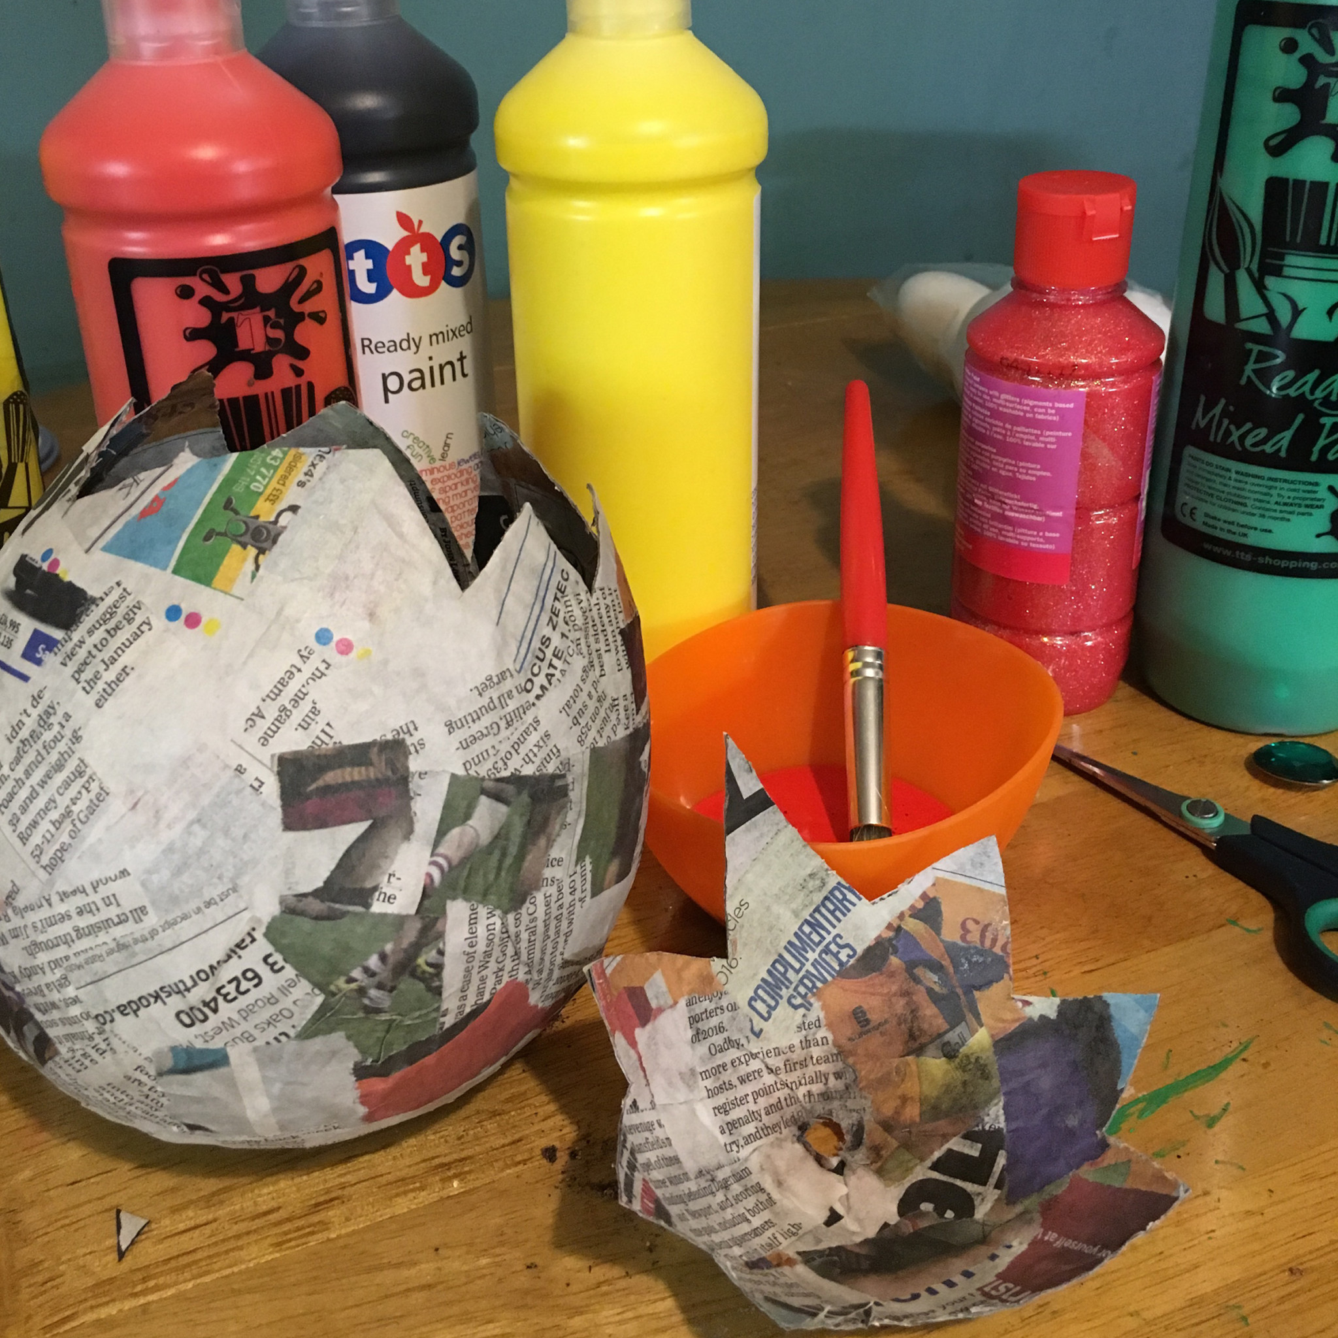
Art
Your task is to sketch the local environment as a wintery scene.

- What does wintery mean?
- What might the weather look like?
- What resources do we need?
- Does the pressure change your art-work?
- What might we need to press lightly for?
- What effect does applying pressure have?
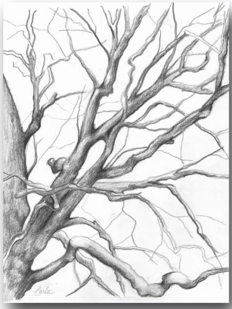
Literacy
Your task is to write your own acrostic poem about the Titanic

- What does each sentence need to start with in an acrostic poem?
- Is your poem going to rhyme?
- Is your poem going to be factual?
- Can you explain how people are feeling?
- Use the five senses to help you.
