# Literacy

Your task is to use your senses to describe the great Fire of London

* What can you see?
* What can you smell?
* What can you hear?
* What can you taste?
* Use adjectives to describe.

# History

Your task is to explain how life is safer nowadays.

* What do we have now that we didn’t have before?
* What items keep us safe around school?
* What do we have in our homes to keep us safe?
* Think about the different rooms at Hazard Alley – what did they have?

# Geography

Your task is to look at the power point with your class then colour in the hot countries near the equator.

* What is the equator?
* What makes the country hot?
* Can you name a hot country?
* Would you like to live in a hot country?
* What would you need to help you live in a hot country?

# DT

Your task is to use junk modelling to create your own house.

* What 3D shapes can you see?
* Which items would make a good foundation?
* Can you see a cuboid shape for the windows and doors?
* What shape would be good for a roof?
* How will you stick the materials together?
* What tools do you need?

# Art

Your task is to create a flame background.

* What medium are you going to use?
* What type of brush strokes will you need to use?
* Which direction will you need to paint in?

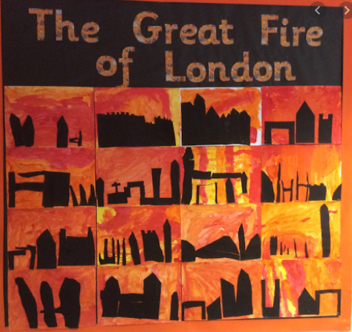

# Art

Your task is to use dark paper to create the silhouettes.

* What shapes will you need to cut out?
* How can you show the roof?
* What does silhouette mean?



# Literacy

Your task is to give advice to someone in an emergency.

* What is the first thing you do if you see smoke?
* What number do you dial?

* What information do you need to tell the operator?
* What services will come to your location?
* How do you stay safe?

# History

Your task is to compare firefighters then to firefighters now.

Look at the slideshow ‘Firefighters then and now’ slideshow (saved on the website).

* What differences can you see between the two pictures?
* What is different about their clothing?
* How is the equipment different?
* Where did they used to have to fetch water from?
* Where does the water come from now?

# DT

Your task is to use things you can find at your house to make a fire engine.

* Can you use junk to make the cab?
* Could you use pencils, kebab skewers or bamboo sticks to make an axle?
* Can you cut perfect circles for wheels?
* How will this make a fire engine?
* How do we stay safe when using tools?

# Art

Your task is use ink to create a flame wash.

* What do we need to remember when using ink?
* What tools is best to apply ink?
* What colours do we need?
* How are we going to make it look like real flames?

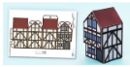

# Art

Your task is put your diorama house together.

* Carefully follow the instructions to create your own diorama house.



# Literacy

Your task is to write your own diary entry.

* Re read entries from Samuel Pepys diary
* How did you hear about the fire?
* What was your first reaction?
* What did you do?
* Use your senses to describe everything around you.
* Are you going to help put the fire out?

# Cookery

Your task is to make your own bread rolls.

* Can anyone at your house teach you how to make bread rolls like the ones that Thomas Farriner was making in London?

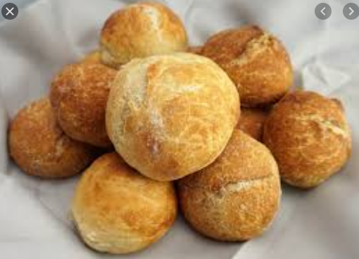

# Art

Your task is to create your own chef plate for your bread roll.

* What will you need to draw?
* Can you draw yourself wearing a chef hat?
* How will you make the arms?
* How will you attach it to the plate?

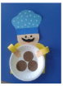

# Maths

Your task is to create a picture using only 2D shapes.

* What are you going to draw?
* What 2D shapes could you use?
* What could you use a rectangle for?
* How many sides does a square have?
* 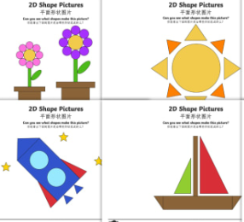Name the properties of a hexagon.

# Maths

Your task is to go on a shape hunt looking for 3D shapes.

* What 3D shapes can you see?
* What shape is a glue stick?
* What shape is a football?
* Can you name eight 3D shapes?
* What properties do they have?
* How many faces does a cuboid have?
* How many vertices does a cone have?

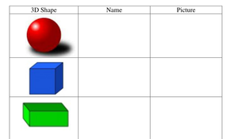

# Maths

Your task is share a selection of toys with a friend.

* How many toys do you have in total?
* How do you share with a friend?
* Do you have to have the same amount or different?
* What does the word ‘equal’ mean?
* If I have 24 bears and I share them with a friend, how many will we have each?

# Literacy

Your task is to use onomatopoeia to write a poem about The Great Fire of London.

* What is onomatopoeia?
* What words would you use to describe the sounds of The Great Fire of London?
* If your poem going to rhyme?

