**Change 4 Life – ways to help you keep fit and healthy** <https://www.nhs.uk/change4life>

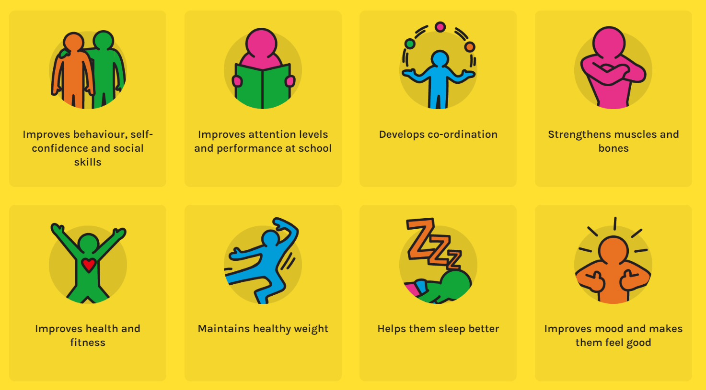

**Visit the homepage and take the quiz** <https://www.nhs.uk/change4life/activities>  **Can you exercise and eat healthily? Take the challenge now….**

**Buzz Lightyear**

<https://www.nhs.uk/10-minute-shake-up/shake-ups/buzz-lightyears-space-run>

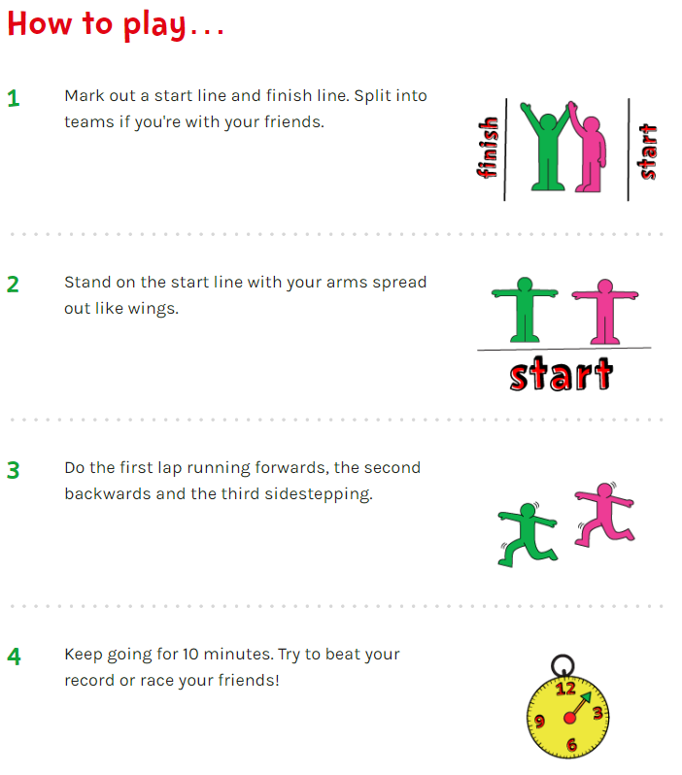

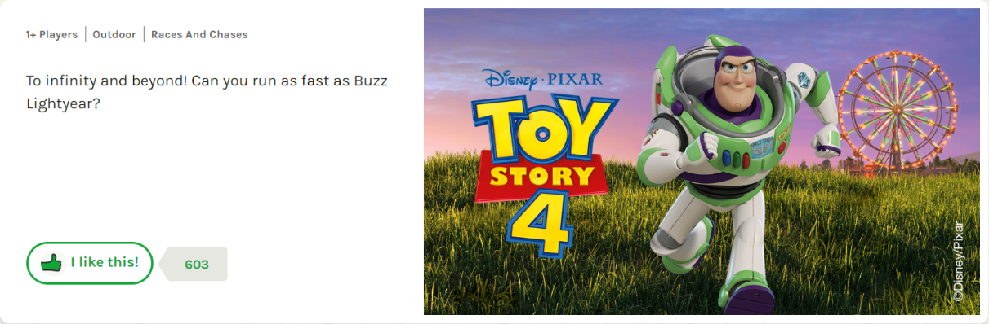

Can you keep going for 10 minutes?

Can you run further than your friends and family…..?

**Find Forky!**

<https://www.nhs.uk/10-minute-shake-up/shake-ups/find-forky>

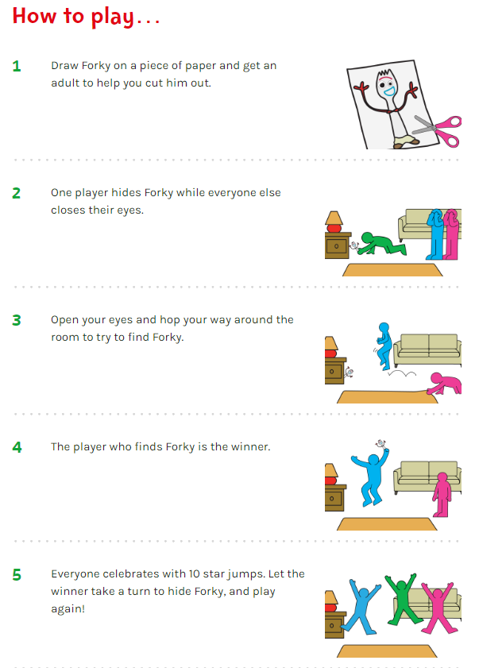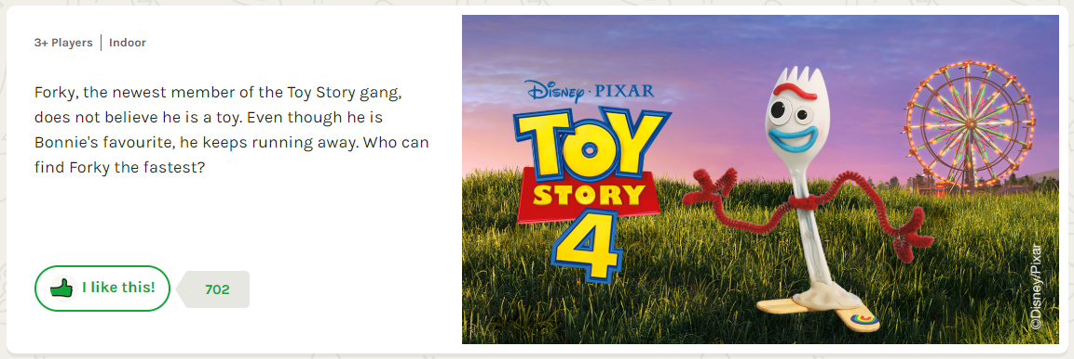

Use your art skills to draw Forky!

**Dash’s Ball Skills**

<https://www.nhs.uk/10-minute-shake-up/shake-ups/dashs-ball-skills>

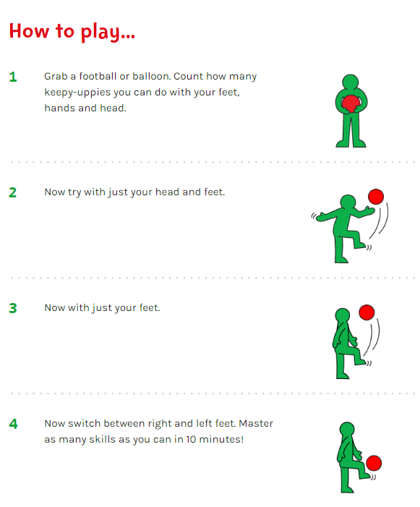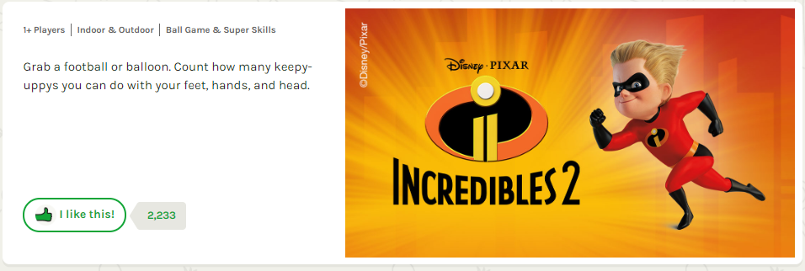

If you are using a ball do this outside!

If you are using a balloon you can play inside. Can you

beat your parents? Brother? Sister?