0-5 6-11 12-17 18-23 23-28

0 x 2 8 x 2

1 x 2

11 x 2

3 x 2

5 x 2

7 x 2

9 x 2

6 x 2

10 x 2

12 x 2

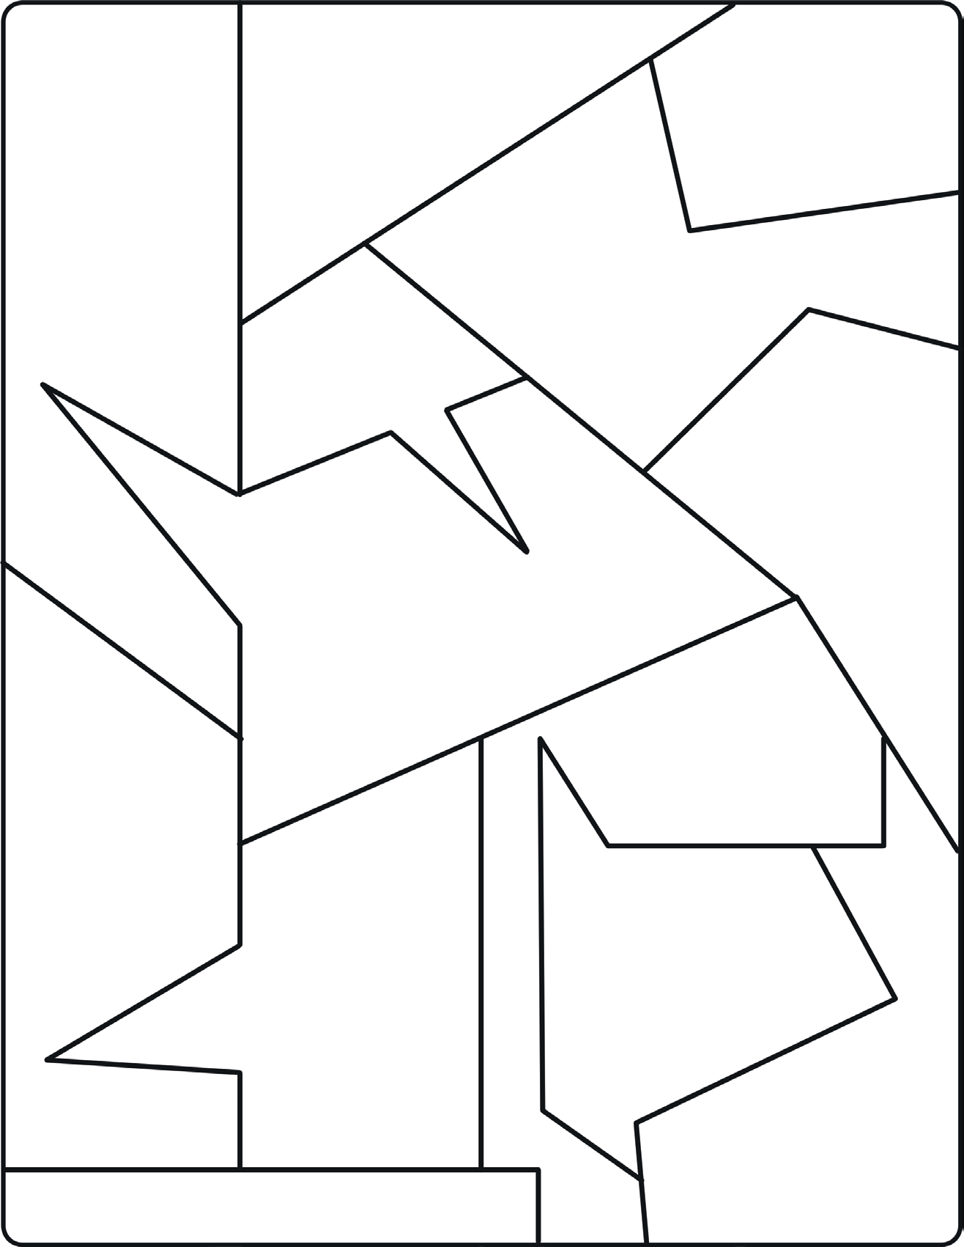

4 x 2

2 x 2

0-10 11-20 21-30 31-40 41-50 51-60

6 x 5 3 x 5

0 x 5

1 x 5

11 x 5

7 x 5

5 x 5

12 x 5

4 x 5

2 x 5

9 x 5



10 x 5

8 x 5

0-20 21-40 41-60 61-80 81-100 101-120

9 x 10 3 x 10

0 x 10

12 x 10

11 x 10

10 x 10

4 x 10

7 x 10

5 x 10

5 x 10



1 x 10

2 x 10

0-10 11-20 21-30 31-40 41-50 51-60 61-70 71-80 81-90 91-100

9 x 10 5 x 10

12 x 2

0 x 5

5 x 2

10 x 10

12 x 5

7 x 5

7 x 10

8 x 5

10 x 2



11 x 2

8 8 x 10