

**Shine week**

**13th – 17th July**

**2020**

**Invent a party game**

**A party is not a party without games. Everyone loves to have fun and play party games. Most of you have probably been to a party and played musical bumps, musical statues and even pass the parcel.**

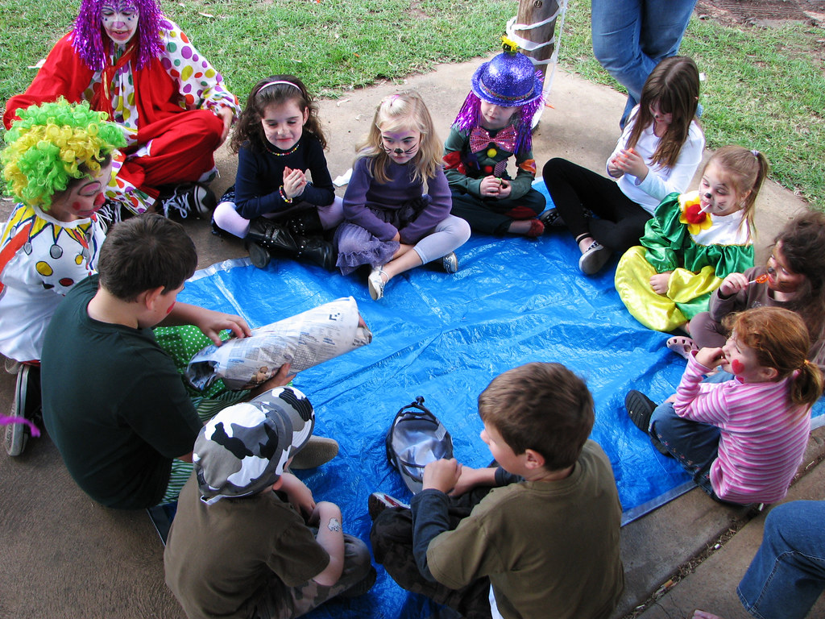

**Why don’t you try and invent your own party game? You could then play it with people at home and have some fun!**

**Below are some tips to help you invent your own party game:**

1. **Use your imagination to think of the type of game you would like to invent (will it be a sitting down or moving around game).**
2. **Have a think about how many people will be able to play (is it for just 2 people or can more people play).**
3. **What items will you need to play your game (you may need paper, pens, chairs, pillows, bucket, ball etc).**
4. **What are the rules of your game? You need to make sure these are simple and clear so everyone playing (no matter what age) will be able to join in.**
5. **Test out your game first with someone to make sure it works, if you need to change anything you can now, maybe something didn’t quite work and needs changing.**
6. **When you know the game works and you have all the equipment and resources you need. IT’S TIME TO PLAY AND HAVE FUN!!**

**The links below show you some game making tips**

<https://www.activityvillage.co.uk/make-your-own-games>

[List of games for all ages to get some ideas](https://www.asphaltgreen.org/blog/rep-it-out-games-for-social-distancing)



Don’t forget to share your game with us on seesaw.