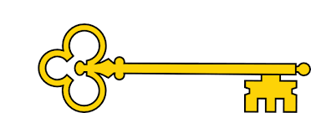

**Facts**

I can explain who Amelia Earhart is

I can explain how cars have changed in the last few years

I can tell you the name of the first plane that flew and when it took

flight

I can explain how planes have changed

I can label a steam locomotive

I can explain the timeline of locomotives

I can tell you who the Wright brothers are

**Previously…**

In EYFS children learnt to Comment on images of familiar situations in the past and compare and contrast characters from stories, including figures from the past.

Year 1

History

Planes, Trains + Automobiles

History

**Next...**

In Year 2 children learn to understand chronology and study of a historical event.

Planes, Trains + Automobiles

Year 1

Spring Term

**Doors this will open…**

Historian

Teacher

Museum curator

Archaeologist

Academic researcher.

Archivist.

Heritage manager

**Vocabulary**

Plane - biplane / pilot / aviator pioneer

Atlantic Ocean

Train – steam engine / locomotive / narrow gauge / railway

Car – petrol / diesel / electric

**Questions**

How have cars changed in the last few years?   
What does it mean if a car is electric?

When was the first plane flight?

How have planes changed?

Who is Amelia Earhart?

Why is Amelia Earhart important?

What is a narrow gauge railway?

What is a steam locomotive?

How are the Wright brothers?

**Links**

Maths – reading dates / timelines

Literacy – Amelia Earhart biography and labelling steam engines

DT –creating a moving picture

**Images**

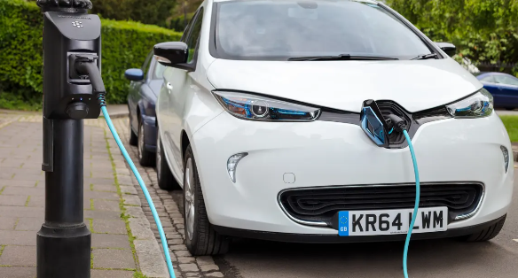 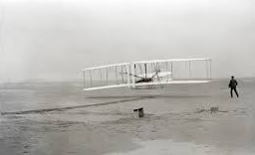 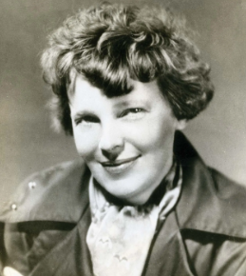 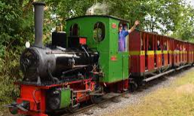

Our Learning Keys