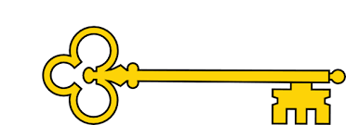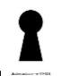

History

**Next...**

In Year 2 children learn to understand chronology and study of a historical event.

Year 1

History

Florence Nightingale

**Previously…**

In EYFS children learnt to Comment on images of familiar situations in the past and compare and contrast characters from stories, including figures from the past.

Florence Nightingale

Year 1

Autumn Term

**Doors this will open…**

Historian

Teacher

Museum curator

Archaeologist

Academic researcher.

Archivist.

Heritage manager

**Facts**

I can explain who Florence Nightingale is

I can explain what a nurse does

I can explain the impact Florence Nightingale has had

I can explain the differences between then and now

I can compare a hospital from the 1850’s to a hospital today

I can tell you what germs are and the impact they can have

I can explain how and why we wash our hands

**Vocabulary**

Germs Investigate

Observe Predict

Timeline Order

More recent Past

Present Germs

Hospital Ward

Clean Dirty

Nurse Doctor

Evidence Conclusion

Change Mould

**Questions**

Who is Florence Nightingale?

What was her job?

Where / when did she live?

Why is it important to keep our hands clean?

Why was Florence Nightingales work important?

What year are we in?

What does a nurse do?

How has Florence Nightingale’s work influenced the way we think about the transfer of germs?

**Links**

Science – investigations / fair experiments

PSHE – personal hygiene / people who help us

Geography – map of the world

**Images**

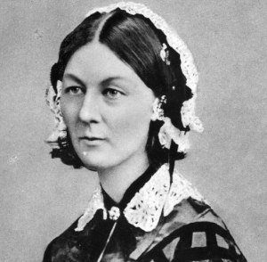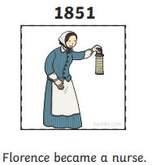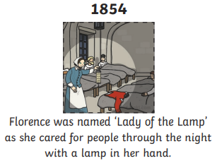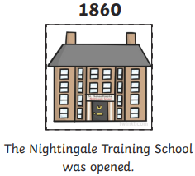

Our Learning Keys