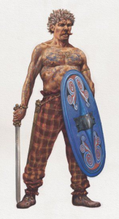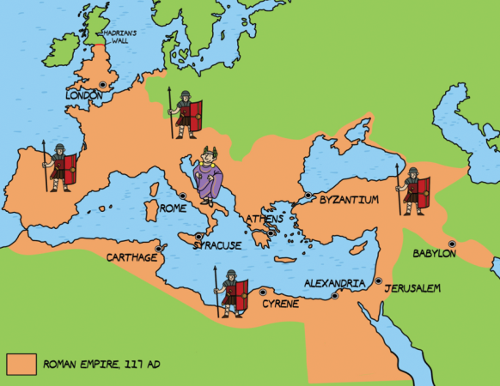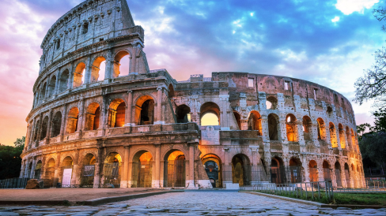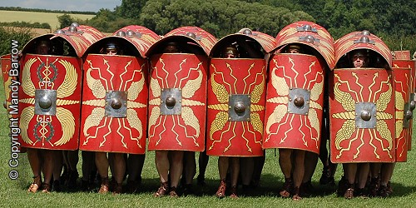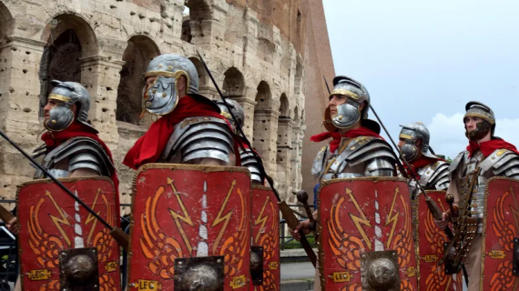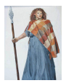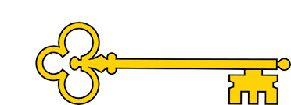

 **Vocabulary**

Ancient history: This is the history of people who lived thousands of years ago in places where writing was being developed (3000BC to 500AD).

Aqueduct: A man-made channel to take water from one place to another, it was often be in the form of a bridge that carries the water.

Archaeologist: A person whose job is learning about the past by digging up and studying remains and objects left behind.

Basilica: A large building used for meetings and discussing legal matters in ancient Rome.

Celts: The people of southern Britain who were living in round houses and small settlements near to their farms when the Romans invaded.

Empire: A group of countries that have been taken over and are ruled by one person or country.

Forum: A large, outside area often in the centre of a Roman town. It was used for public gatherings, shop stalls and celebrations and was surrounded by public buildings, temples and statues.

Invasion: An unwelcome arrival of a large number of people (e.g. an army) who usually come with force and may cause harm.

Legion: A large group in the Roman army usually made of 5000 soldiers.

Rebellion: An act of rebellion is when people refuse to follow someone who is in charge, in a rebellion people may try and overthrow the ruler

Villa: A Roman villa is a large country house.

:

Next...

In Years 4, 5 and 6, we will learn about the Ancient Egyptians, WWII, Stone age, iron age, Vikings and Anglo Saxons.

Previously…

Year 1: Label time lines with words or phrases such as: past, present, older and newer.

Year 2: To understand chronology and study of a historical event.

**Images**

History

**Facts**

* 753 BC Rome is founded. Romulus becomes the first king.
* 509 BC Rome becomes a republic ruled by elected citizens called senators rather than a king.
* 73-71 BC A gladiator called Spartacus leads a revolt against the Romans.
* 58-51 BC The Roman invade France, Belgium, western Germany and northern Italy and control many lands around the Mediterranean sea.
* 55-54 BC Julius Caesar tries to invade Britain twice but is beaten back by the Britons.
* 27 BC Rome becomes an empire. Augustus Caesar becomes Rome’s first emperor.
* AD 43 The Romans invade Britain under the orders of Emperor Claudius.
* AD 60 Boudicca leads the Iceni tribe in a revolt against the Romans.
* AD 71-78 The Romans conquer Wales and northern England.
* AD 83 The Roman army defeats the Scottish Highlands tribes at the Battle of Mons Graupius.
* AD 122 The building of Hadrian’s Wall to defend the northern limit of the Roman Empire in northern England begins.
* AD 211 Britain is spilt into two provinces called Britannia Superior and Britannia Inferior.
* AD 250 New enemies, the Angles, Saxon and Jutes, repeatedly attack Britain.
* AD 401-410 Roman soldiers leave Britain to protect other parts of the Roman Empire.

**Questions**

 Who were the Romans?

 What was life like for them?

 How do we know about the Romans?

Who was Boudicca?

Why did the Romans invade Britain?

**Doors this will open…**

Historian

Teacher

Museum curator

Archaeologist

Academic researcher.

Archivist.

Heritage manager.

**Links**

 Literacy: Boudicca’s diary, Escape from Pompeii

 PSHE: To understand the lives of others.

 Geography: Where in the World did the Romans invade and settle?

Our Learning Keys

The Romans

**Year 3**

**Spring**