

**Shine week**

**13th – 17th July**

**2020**

**Gardening**

**Why not learn a new skill and have a go at some gardening today? Here are a few ideas of activities you might like to try. Some of the activities below are underlined. Click on these to find out more.**

* **Weeding**
* **Watering the plants**
* **Sweeping your patio, driveway, path, or decking**
* **Planting some seeds**
* **Planting a new plant**
* **Digging over a flowerbed**
* **Deadheading a plant**

**You will need an adult to help you with the next two activities. You MUST NOT try these by yourself.**

* **Cutting the grass**
* **Pruning a plant**

**Equipment you might use…**

Fork

Seeds

Broom

Trowel

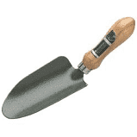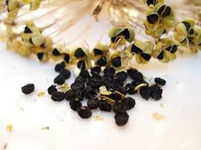

Bucket

Compost

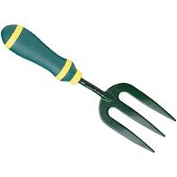

Watering Can

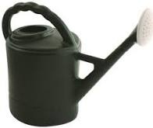

DO NOT USE THESE WITHOUT AN ADULT HELPING YOU

Lawnmower

Secateurs

