Home Learning for Reception

November 2020

Dear Children and Families,

Please find below information on resources that you may wish to use at home. These are websites and apps which can be used during self-isolation, any possible future lock-downs or for extra learning during evenings or weekends if you should wish to do some.

Seesaw - https://app.seesaw.me/#/login

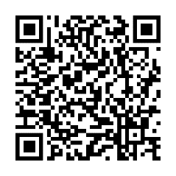Seesaw is an app and website which allows us to share the children’s learning between school and home. You will need to use the QR code for your child’s class to start off (found below) and you will be able to upload photos, videos, documents and messages to the teachers, who will then respond to you. The children can also comment on each other’s learning and these comments are moderated by school staff. Please be aware that logging in using the QR code confirms that you agree to the terms and conditions of the service.

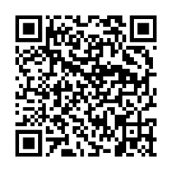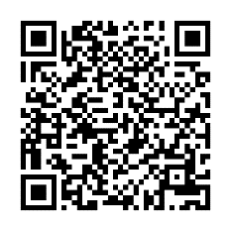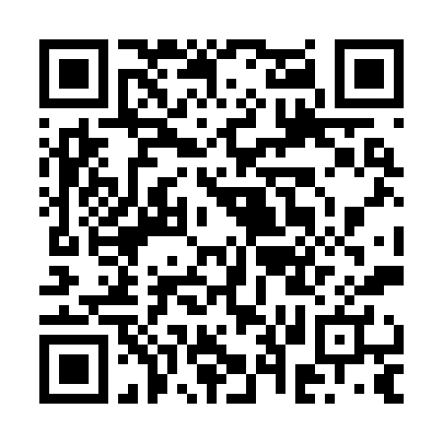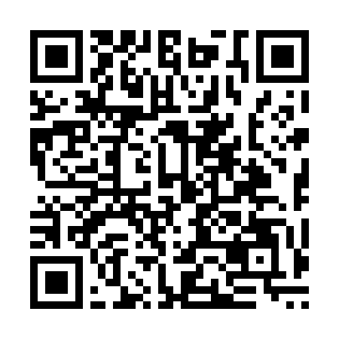Mercury Chicks QR Mercury Lambs QR Jupiter Piglets QR Jupiter Hedgehogs QR Jupiter Rabbits QR

Times Tables Rock Stars - https://play.ttrockstars.com/auth

Called TTRS for short, this is a website which helps children to learn their times tables and related division facts. Each child has been given a username and password and has been set certain focus times tables as their target. To get to these tables, please click on the Garage tab. If you click on the Studio tab, you will be given all of the times tables up to 12 x 12 and this can be quite demoralising for younger children but it’s well worth a go if you’re feeling brave!

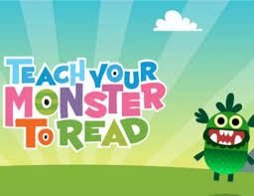

Teach Your Monster to Read - https://www.teachyourmonstertoread.com/

Children can learn to read using this fun online game. It teaches them everything from letters and sounds to reading full sentences. The ‘first steps’ are to be completed independently for the algorithms to capture the child’s ability and then eBooks are to be read alongside an adult.

PhonicsPlay - <https://www.phonicsplay.co.uk/>

We use PhonicsPlay regularly at school to teach the children phonics and early reading so the children will have their favourite game already. If you click on the ‘resources’ tab, some of these games are free to use at home without a subscription. Enjoy!

If you have any difficulty accessing any of these resources, please watch the support videos found at;

<https://www.leedonlowerschool.co.uk/year-1-and-2/>

If you still need further information or help, please contact Gemma O’Reilly via her email;

[goreilly@leedonlowerschool.co.uk](mailto:goreilly@leedonlowerschool.co.uk)

Many thanks,

The Reception Team.