

**Shine week**

**13th – 17th July**

**2020**

**Fitness Obstacle Course**

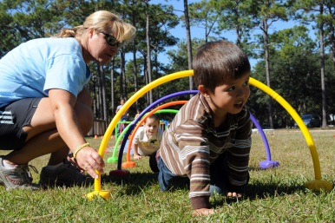**Some people, when they listen to the word “fitness”, they think of weights and muscles but fitness involves much more than that. Fitness is the condition of being physically fit and healthy. Why not do it and HAVE FUN?**

**What you need to plan an obstacle course is:**

1. **Find the space or area (indoor, garden, park)**
2. **Think about the activities you can do or you want to do (agility, balance, strength…)**
3. **Try to find the objects you are going to use (chairs, skipping rope, socks, plastic bottles, cardboard boxes…)**
4. 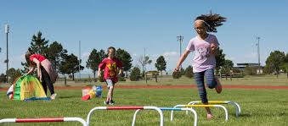**Plan your obstacle course on paper**
5. **Set it out**
6. **HAVE FUN!!**

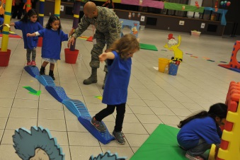**Click the links below for more information and ideas**

* [Building and obstacle course tips](•%09https:/www.familyeducation.com/fun/indoor-activities/indoor-obstacle-course)
* [Ideas and photos of obstacle courses](https://tinyurl.com/ycz4qyjg)
* [Fun activities for an obstacle course](https://www.mummypages.ie/20-fun-activities-for-a-back-garden-kiddie-obstacle-course)