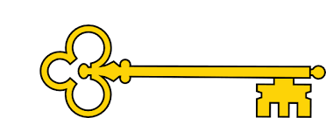

**Next...**

In Year 3 children will be able to add and subtract 1 digit numbers from 2 digit numbers as well as 2 digit numbers from 3 digit numbers (crossing 10’s)

Year 2

Addition and Subtraction

**Previously…**

In Year 1 children were adding and subtracting within 20 (crossing 10). They could find and make number bonds and added by counting on and subtracted by counting back.

**Facts**

I can add and subtract across 10

I can subtract from a 10

I can add a 1 digit number and a 2 digit number across a 10

I can find 10 more and 10 less

I can add 2 two digit numbers (both across and not)

I can subtract two digit numbers (both across and not)

I can solve mixed addition and subtraction number sentences

I can compare number sentences

I can solve missing number problems

**Vocabulary**

Part whole model

Total / altogether / equals

Addition / add / plus / more

Subtract / take away / less / how many left / minus

Fact family

Column addition / subtraction

Inverse operation

Partition / place value

**Questions**

What does each circle represent on a part whole model?

How many different number sentences are there in a fact family?

Is there a relationship between the represented numbers?

Which direction will your finger move on a 100 square if you are finding 10 more/less?

How do you partition a number?

**Images**

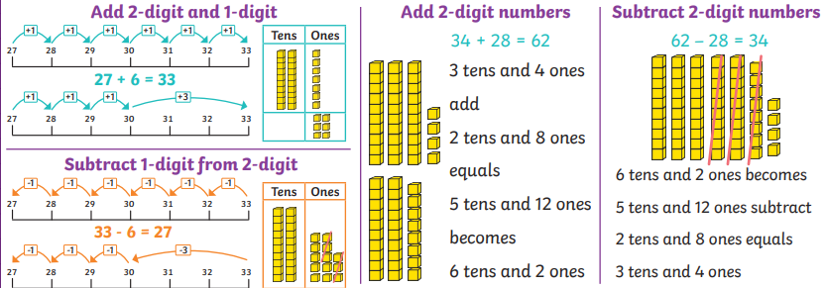

Addition and Subtraction

Our Learning Keys

Year 2

Weeks 5 - 9

Maths

**Doors this will open…**

Data analysis

Statistician

Scientist

Engineer

Builder

Banker

**Links**

English – worded problems